BoK Document Cyber Security 4th Semester of Aleksandar Garkov

Table of Contents:

1. BOK ESSENTIALS 2
   1. Understanding of the Basic Hacking and Pentesting Process 2
   2. Threat + Risk Analysis + CIA 2
   3. Setting Up VMWare and Pentesting Environments
   4. Footprinting, Reconnaissance, and Social Engineering 2
   5. Law & Ethics and Responsible Disclosure + GDPR 2
   6. SQL INJECTION 2
   7. Path Traversal, (remote) File inclusion and Command Injection 2
   8. XSS & CSRF 2
   9. Network Scanning and Enumeration (incl. Sniffing) 2
   10. Network Separation and Segmentation 2
   11. VPN: How to manage a Web Shop with Secure Remote Access 2
   12. WiFi Hacking 2
   13. Password Cracking (system and network) 2
2. BOK ADDITIONAL 3
   1. Web Application Firewalls 3
   2. Host Intrusion Detection (HIDS) and Prevention
   3. Network Sniffing and Spoofing 3
   4. IT Basic Monitoring
   5. Docker and Container Security
   6. Identity and Access Management
3. BOK SPECIALIST 4
   1. Secure By Design 4
   2. Operating Systems 4
4. OVERALL CONCLUSION 5
5. REFERENCES 6

# BoK Essentials

<your introduction and your personal BoK approach explained here> Sprint 1 and 2 (first 6 weeks) deal with the BoK Essentials.

* 1. Understanding of the Basic Hacking and Pentesting Process

Every pentest goes through a defined process to be completed. This process has many stages, but one doesn't need to go through them all. Most of the time It depends on who is making the pentest, for example, an ethical hacker will get to the point where he/she will keep the privacy of the company without stealing the information. The point of this is to pinpoint the company where their security weaknesses, while a gray or black hat hacker might abuse the gathered information. This is a picture of the steps of pentesting:

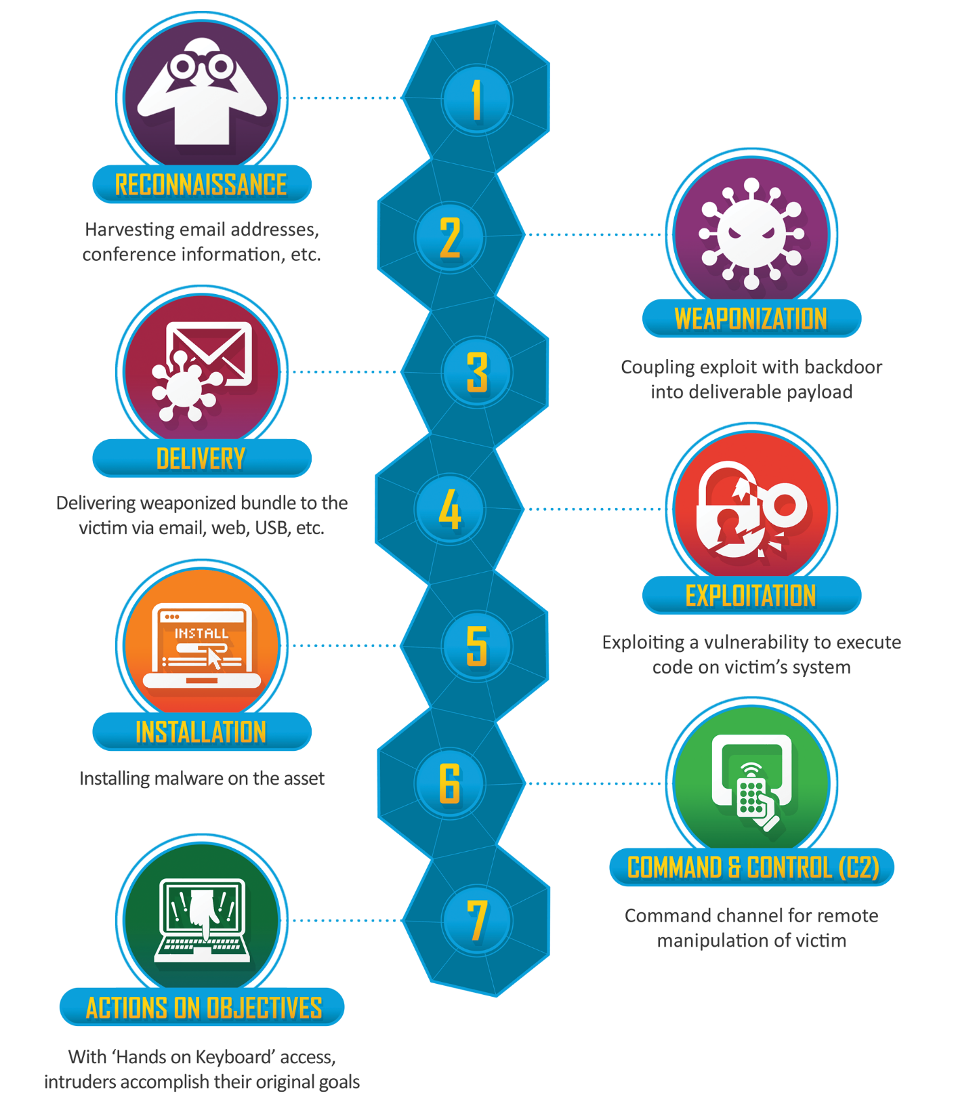

Ethical hackers and pen-testers normally stop hacking after the exploitation step.

A pentester needs to agree with a company/customer to sign a contract for a specific service. In the contract, it should be explained that the pentesting side must handle the information of the client with care and will not perform malicious activities on the system without prior agreement with the other side about it. A complete pentest contract includes:

* an indemnification clause (signed by the client) that allows you to test and address liability (see permission memo).  
  For liability, it is normal and necessary to agree that, even though the responsibility for careful testing is with the testers, any remaining risk in testing is for the client. Testers cann**ot** be liable for any damages caused by testing!
* a confidentiality agreement (signed by all testers).
* information about the scope and tested systems and environments (location, range, DNS names, etc.),
* test origin (ip-address from where tests will be performed, in our case the seclab's public IP) and test times/period of testing so that the client can monitor the testing and be able to distinguish your tests from real attacks.
* escalation procedure in case of an incident/emergency

After a complete pentest, a report must be conducted in written form, which will be presented to the customer with the findings, methods, and conclusions about the test.

There are many examples of reposts such as this:

<https://www.sans.org/white-papers/33343/>

Besides the document, a presentation with a summary of the findings and advice is an additional step to a good delivery.

source: Fontys ICT

* 1. Threat + Risk Analysis + CIA

There are many possible threats to an organization that can impact its performance and security such as:

* malware (virus, trojan horse, worms, etc.)
* spam
* phishing
* spear phishing
* adware
* man-in-the-middle attack
* ransomware
* Denial of Service (DOS and DDOS)
* advanced persistent threats

Every threat has a purpose and an actor aiming to achieve something with it.

Motivations could be geopolitical, profit, ideological, pure satisfaction, discontent, or ideological violence (terrorism).

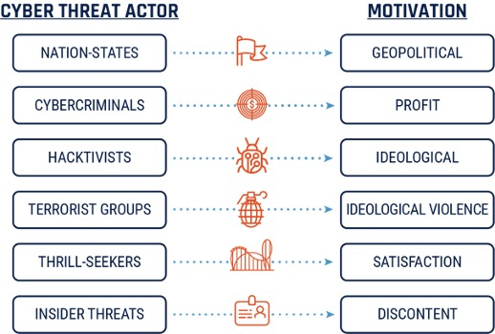

A CIA- matrix stands for Confidentiality, Integrity, and Availability. The goal of the organization is to maintain those factors, ensuring the security of them. They are like big dimensions that include many attributes corresponding to a different threat. Example of CIA-matrix:

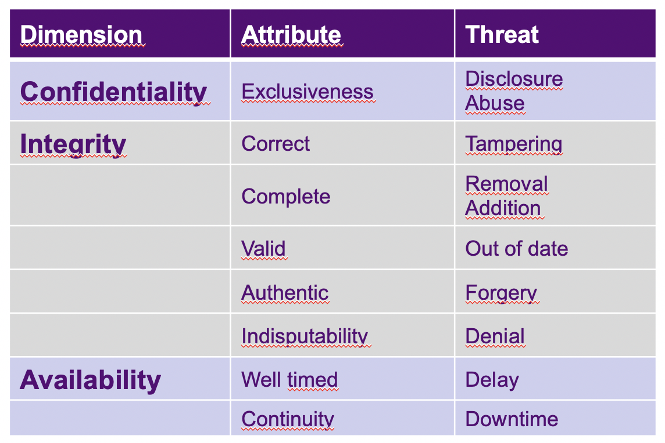

By making a risk analysis, the probability and impact of a certain malware attack are evaluated and structured as a risk table. The risk is calculated as follows:

Risk = Probability * Impact

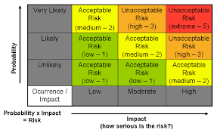

The different types of impact can be downtime, recovery time (at work) claims from customers, law-breaking fines, environmental damage, injuries, and even deaths.

Me and my teammates had to do an exercise, which required a risk analysis to be made for a preferred company by us. We chose one of the examples listed in the course which was Coolblue web shop migrating to a cloud platform.

As you can see in the image below, stealing confidential business data in this case had a medium probability, but at the same time one of the biggest impact levels, raising it to the top of the risk level scale. In addition, if exploited, it could give competitors an advantage or the data could be sold to unauthorized people, leading to financial and reputational damage.

DDoS attack was the next possible critical threat because we are talking about cloud migration and a denial of service might interfere with it very badly and could lead to the loss of important data, financial and reputation damage, downtime, and incident handling costs.

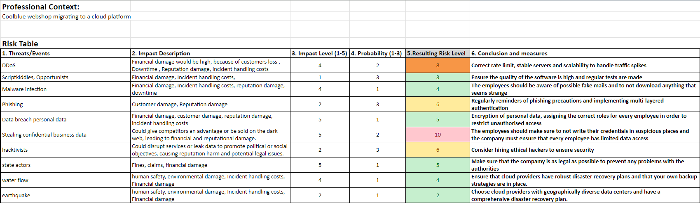

After this university lesson, my group and I presented what we did in front of our peers. After that the others presented and it was interesting to see how different threads are ranked based on the case they are working with.

* 1. SETTING UP VMWARE AND PENTESTING ENVIRONMENTS

In my first workshop at the university, we set up a Virtual environment in which we would work until the end of the semester. For the first steps in cybersecurity, we have installed Kali Linux and DVWA.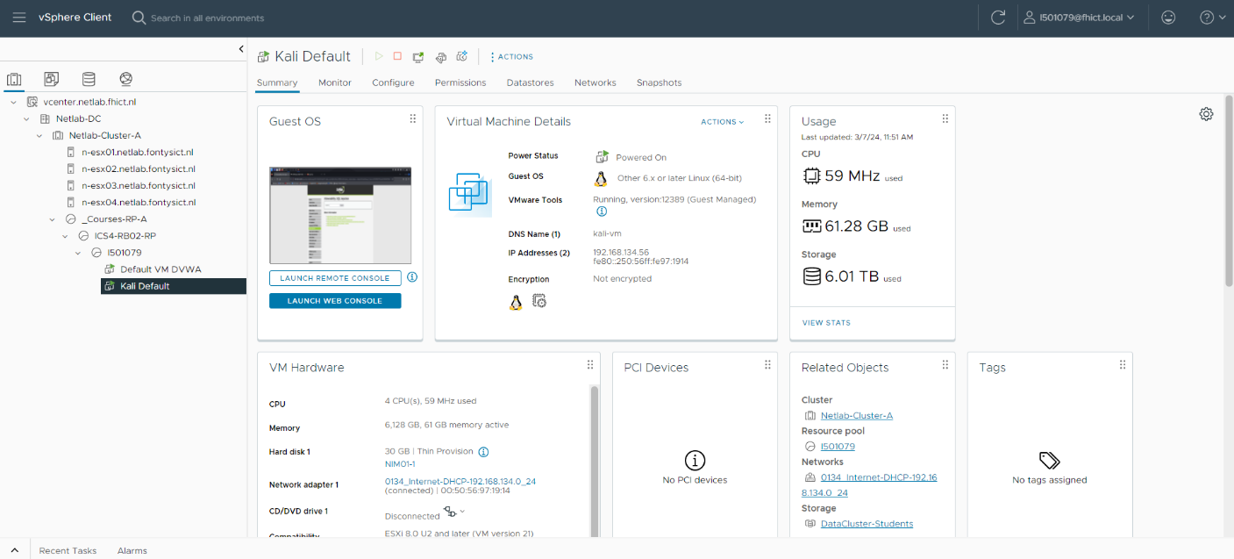

* 1. Footprinting, Reconnaissance, and Social Engineering

**Footprinting** (also known as reconnaissance) and Social Engineering are an important phase of the pentesting process. By intelligence gathering, one learns a lot about an organization/target, how it operates, key figures, security posture, and any potential vulnerabilities. It is the prior step of Network Scanning and Enumeration, and it can be done by searching publicly available sources like the Internet, published materials, TV, radio, etc.

**Google Searching (Google Hacking) is a term used to describe the act of using advanced operators in search engines to find exploitable targets.**

**An example of this topic can be found on this website:**

[*https://www.blackhat.com/presentations/bh-europe-05/BH_EU_05-Long.pdf*](https://www.blackhat.com/presentations/bh-europe-05/BH_EU_05-Long.pdf)

There are many Network information discovery tools including web crawlers, the harvester, WHOIS queries, etc, which we soon will be exploring.

**Social engineering is a term used to describe the act of persuading people mentally and setting up traps to perform actions that lead to the exploitation of confidential information, although it is not allowed to be present in a pentesting, because it might be seen as fraud.**

For the first exercise, I had to find at least 3 people including email addresses that work within a large international Company using social media. It was relatively easy because, on social media like LinkedIn, people leave their email addresses if somebody wants to contact them and they usually write in their profile their professional history including their current workplace. For privacy reasons, I will not include them in this document.

The next thing that I searched for Is how the website of fontys.nl looked in 2012 (12 YEARS ago) using the Wayback Machine (https://web.archive.org/)

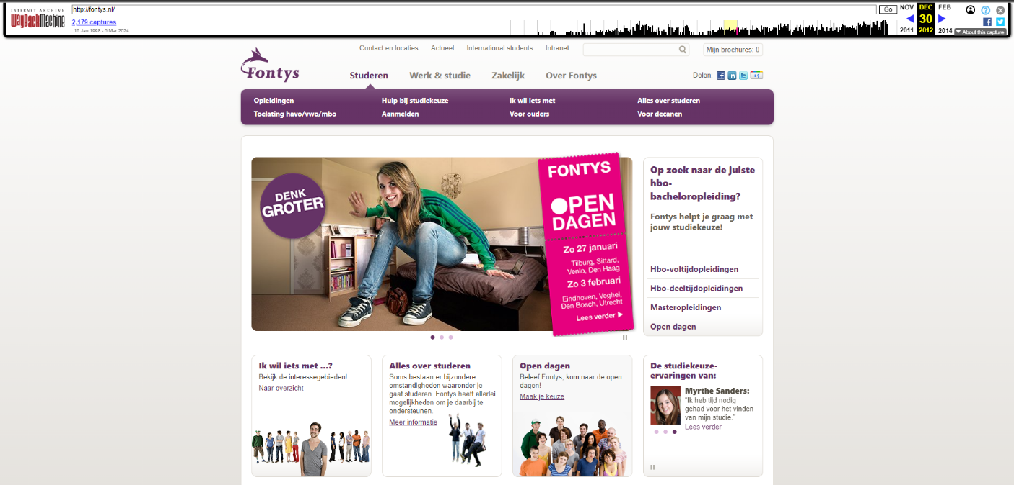

I also managed to find which DNS and email servers are used by Fontys and fhict

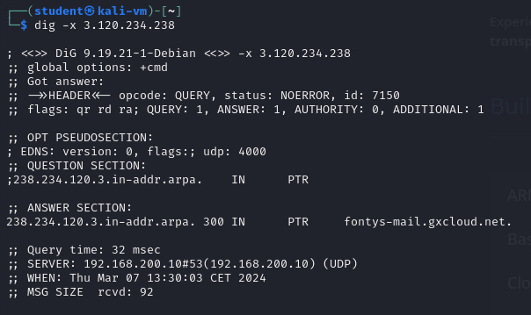

Then I ran a command and used “whois //todo

Furthermore, I used theHarvester from Kali Linux and got information about 3 big websites: facebook.com, google.com, yahoo.com

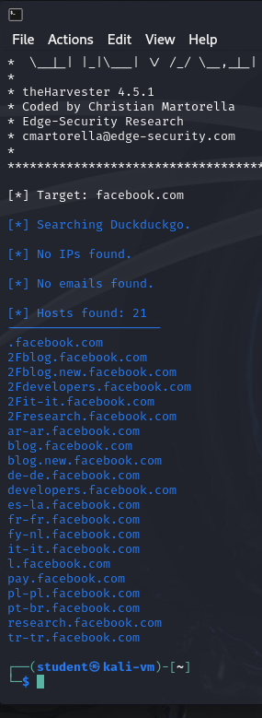

I was able to see in-depth information about them like hosts, but the other ones were not found with the source I have used.

In the afternoon all the groups did something exciting. We had the task to “Scan our Environment”, which meant going around the university and searching for some vulnerabilities that could be exploited for malware attacks. Every group had to go to a specific location and our war Fontys R4/5. Of course, our university is very well protected, but we decided that some possible doors could be a path for malware. For example, every computer that is being used by teachers and students has its ports open. This was a potential way of stealing somebody’s information by putting a keylogger that could be very hard to spot between all those cables. 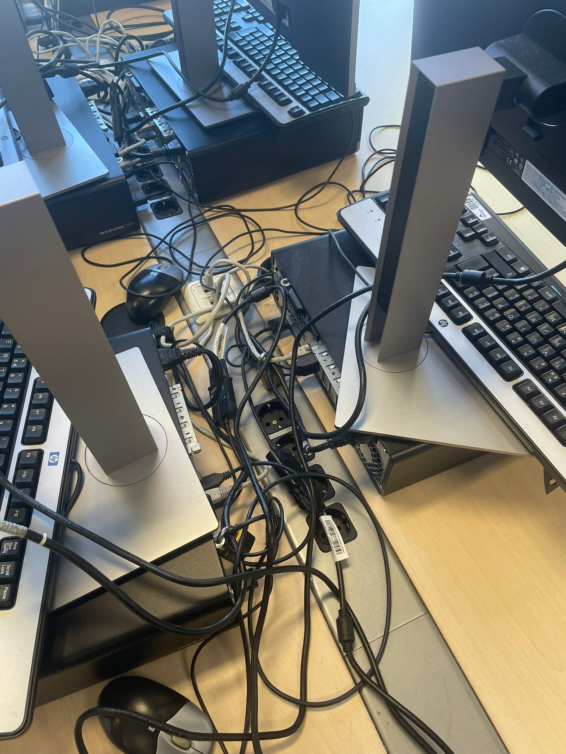

We also found that many endpoints could be accessed with an ethernet cable.



Besides that, it was tough to get access to important stuff. On the other hand, when we all presented what we found at the end, the other group shared that they found a way to get access to a fully unattended server room.

* 1. Law & Ethics and Responsible Disclosure + GDPR
* Do not use computers to harm others.
* Respect the privacy of others.
* Discuss or complain about illegal or unethical use of computer facilities.

Those are some of the most important cyber principles that belong to the ethical way of working in the cybersecurity field. It is more about moral principles.

The Law is more about authoritarian rules and guidelines that people should follow, otherwise, there will be legal consequences.

I and my team researched known cybercrime cases. Everybody found a case from their country and then presented it in front of the class. An interesting fact was that most of the articles about those cases mentioned only the origin of the attackers and the affected organizations. The explanations for the attacks were brief and we didn’t find more in-depth information on how exactly the penetration happened.

After that, we did the most interesting thing in my opinion and it was lock picking.

In the beginning, we were given a lock-picking toolkit to exercise on and after that, we went into a server room and tried to open the actual lock of the server. To my surprise, I managed to unlock it as well as 2-3 people from the other groups.



Responsible Disclosure is a policy in which a company or an organization allows attackers to give information on vulnerabilities, as long as it doesn’t disturb the workflow or moral and legal principles. Some companies even give rewards to attackers who successfully hack their businesses. An example in the Netherlands is Rabobank:

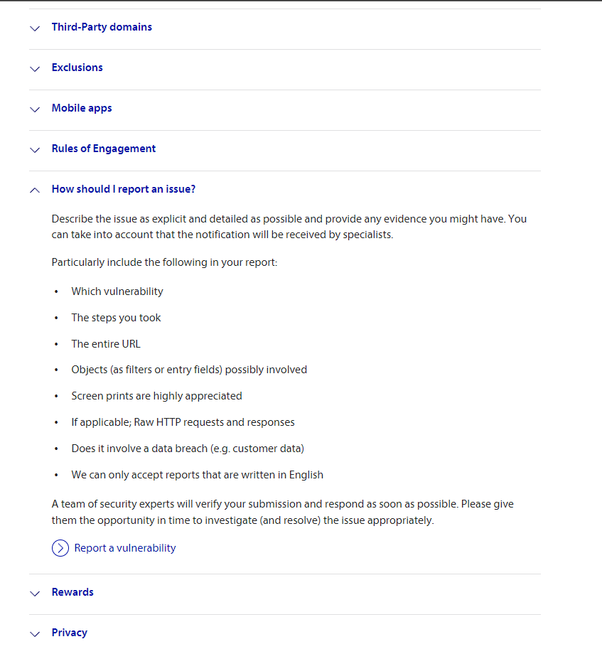

There is an explanation of what falls into the rules of engagement, the rewards, what should be excluded from the research, etc.

Another example is Phillips: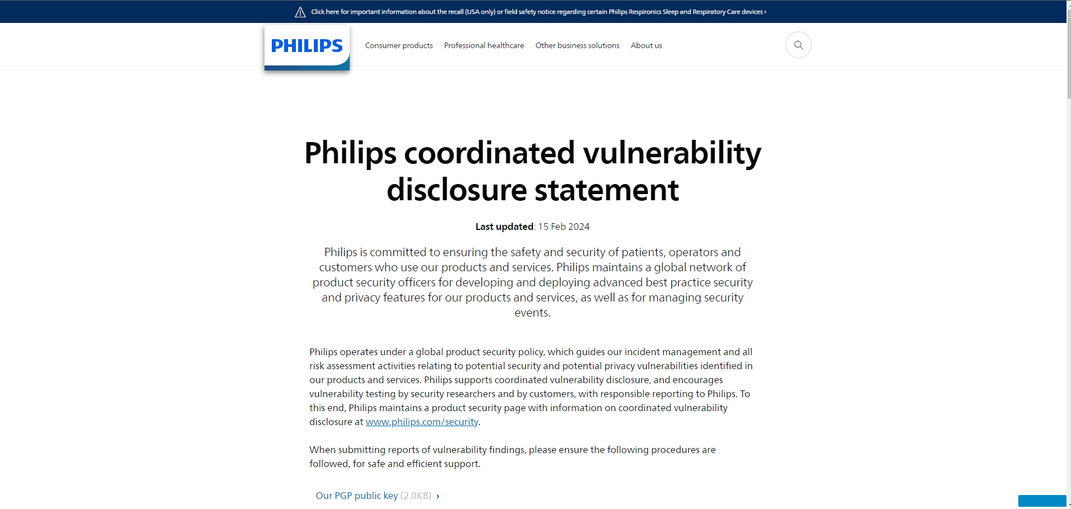

* 1. SQL Injection

Most of the time an application has a database with which it communicates to get, update, write, and delete information. A common example might be a contact form with fields to input information which would be sent to the database. SQL injection would be for example if we try to “inject”/insert additional SQL code that will be executed along, allowing us to get information from different sections of the database, if it is not protected enough.

To test this myself, I used the already installed DVWA, the mock web application that is specifically designed to be vulnerable.

Of course, I lowered the security level, because I am still a beginner.

So for the first SQL injection, I figured out that this field should send a SQL query like this “SELECT * FROM users WHERE id =ID;”, where ID is the inputted value. The following expression “1 OR '1' = '1'” is always true. So, if we write “SELECT * FROM users WHERE id = 1 OR '1' = '1'; “, the database should give me a list with all the users:

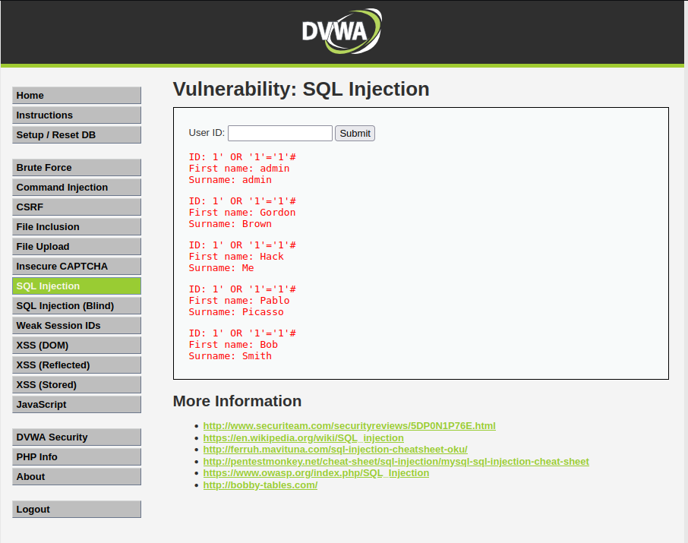

Also, I managed to get the users’ hashed passwords:

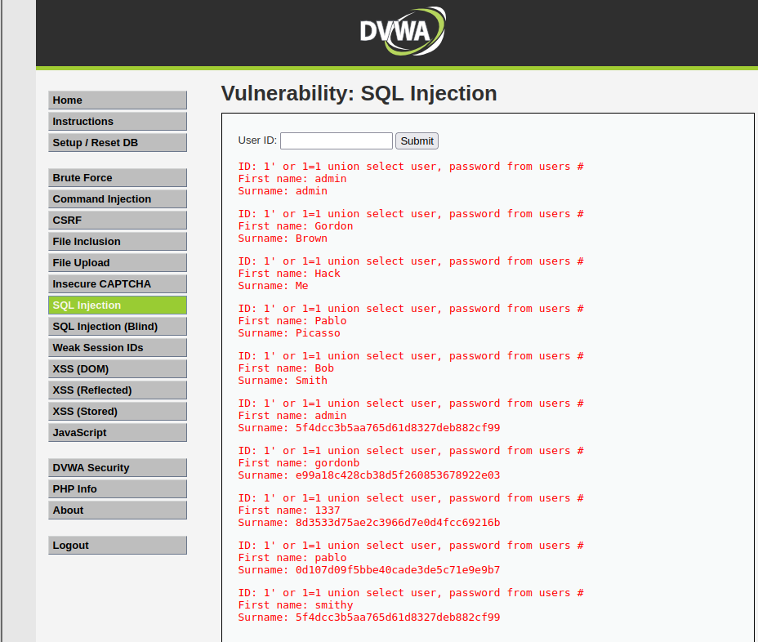

And from now on we can just use an online decoder:

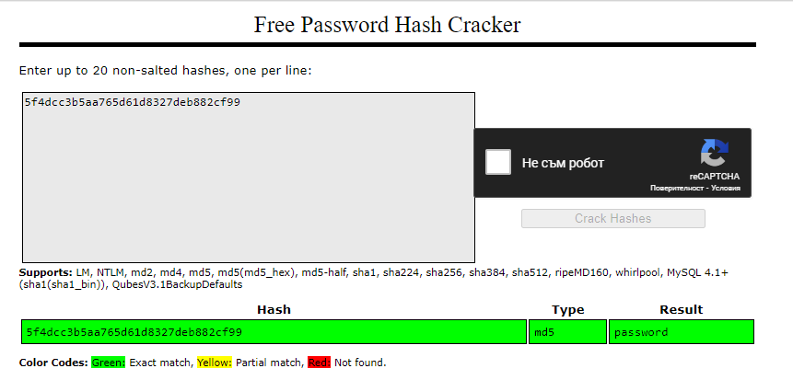

There are many more examples of possible exploitation with this level of security here:

<https://medium.com/@tafiaalifianty/low-level-sql-injection-in-dvwa-41928b7206c6>

and here:

https://www.stackzero.net/how-to-hack-with-sql-injection-attacks-dvwa-low-security/

Another more advanced SQL injection is to construct an attack combining different techniques. For example, a database contains a different table called users, with columns called username and password. In this case, I am performing an SQL Injection UNION attack that retrieves all usernames and passwords and uses the information to log in as admin, but first I must determine how many rows will I get from the table to match with the union and to double check if the columns match string input.

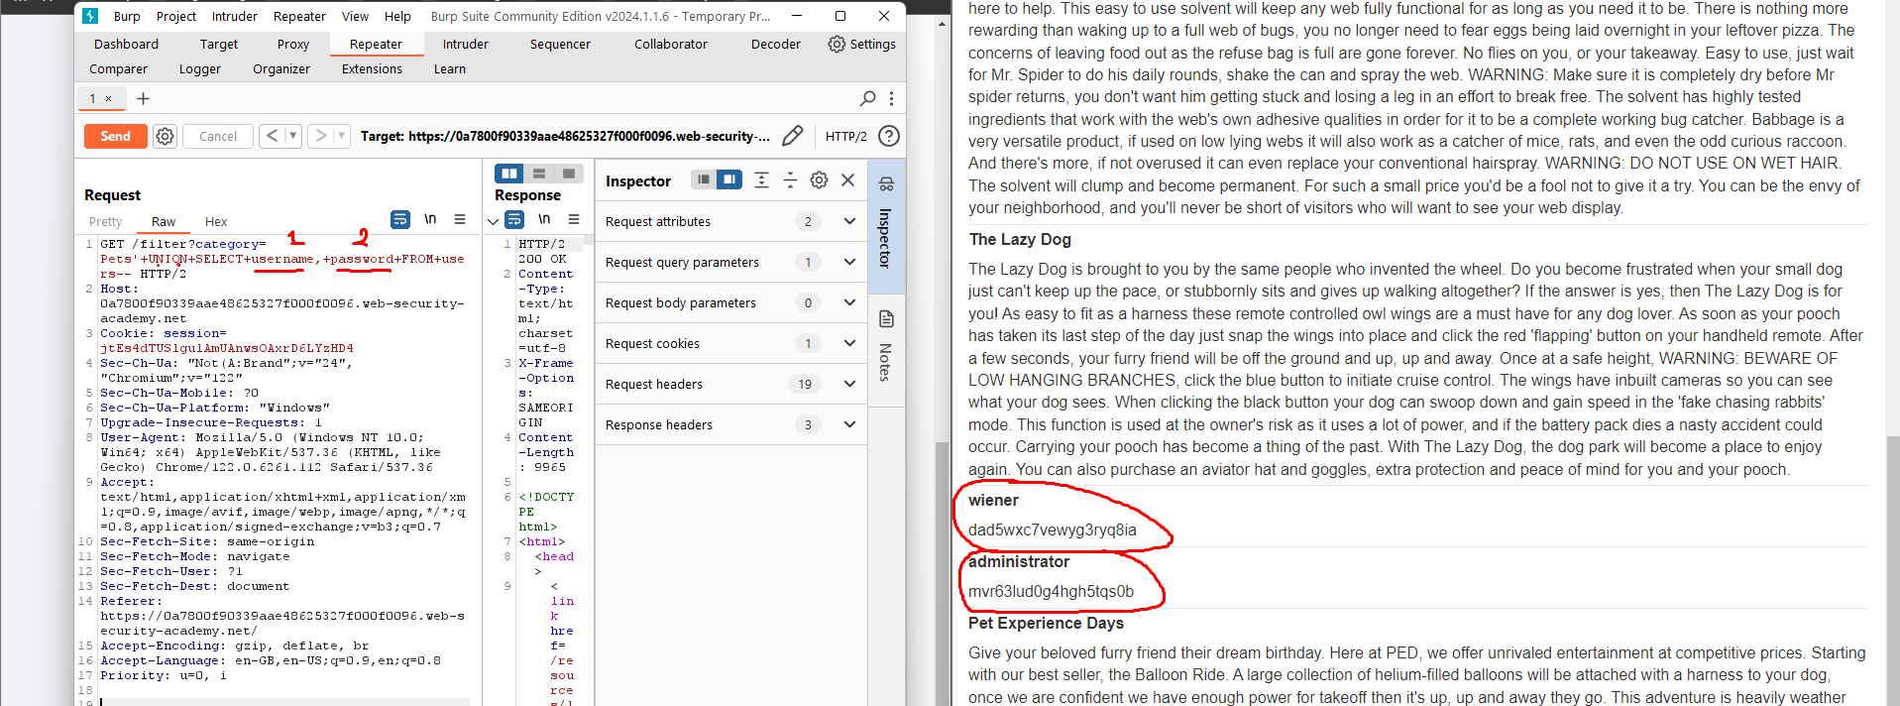

* 1. Path Traversal, (remote) File inclusion and Command Injection

**What are the common things between Path Traversal, File Inclusion, and Command injection?**

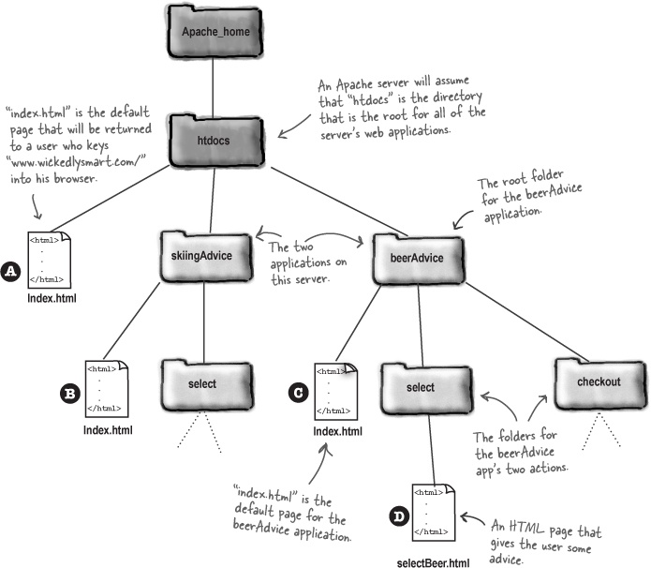

All three involve exploiting vulnerabilities to gain unauthorized access or execute unintended commands on a system. They often rely on manipulating input data, such as file paths or commands, to trick the system into performing unintended actions.

**What are the differences?**

1. Path Traversal:

What it does: Exploits the system's file path handling to access files or directories outside of the intended scope.

How it works: By manipulating input to trick the system into navigating to files or directories it shouldn't be able to access.

1. (Remote) File Inclusion:

What it does: Involves including files from a remote server into a web application, allowing an attacker to execute malicious code.

How it works: By manipulating file inclusion mechanisms in the application to load external files, often from an attacker-controlled server.

1. Command Injection:

What it does: Permits an attacker to execute arbitrary commands on a system, often within the context of a vulnerable application.

How it works: By injecting malicious commands into input fields or parameters, the system executes unintended commands with the same privileges as the vulnerable application.

A path traversal is used to get access to files outside the root directory. To prepare more for this exercise I practiced Linux commands with this site:

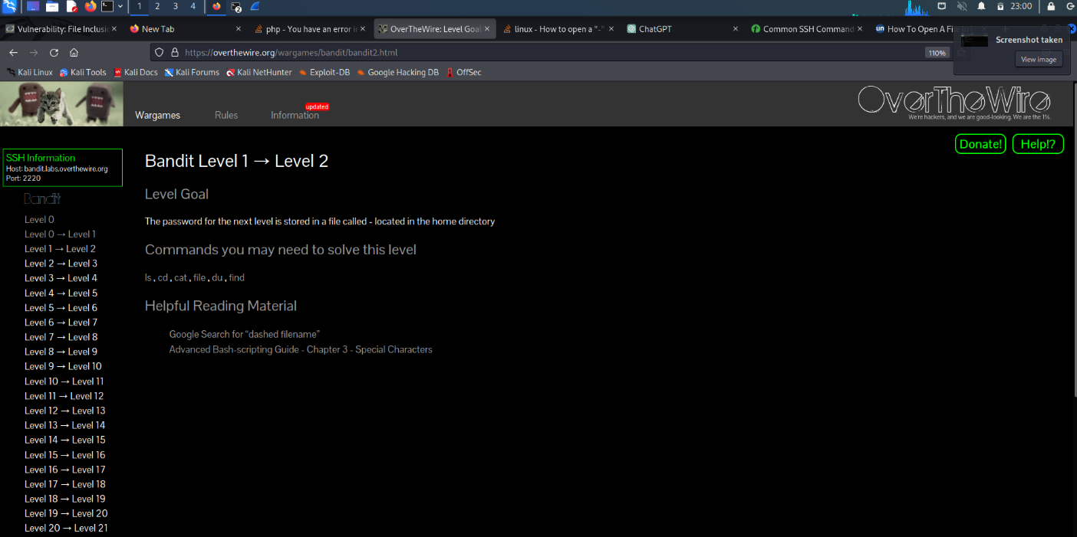

There I learned what SSH is and how to connect to hosts.

I also learned about the basic principles of a web server like Apache or IIS and where the documents of a website are located for that type of server.

Then I tried to get to the root folder of the DVWA like this:

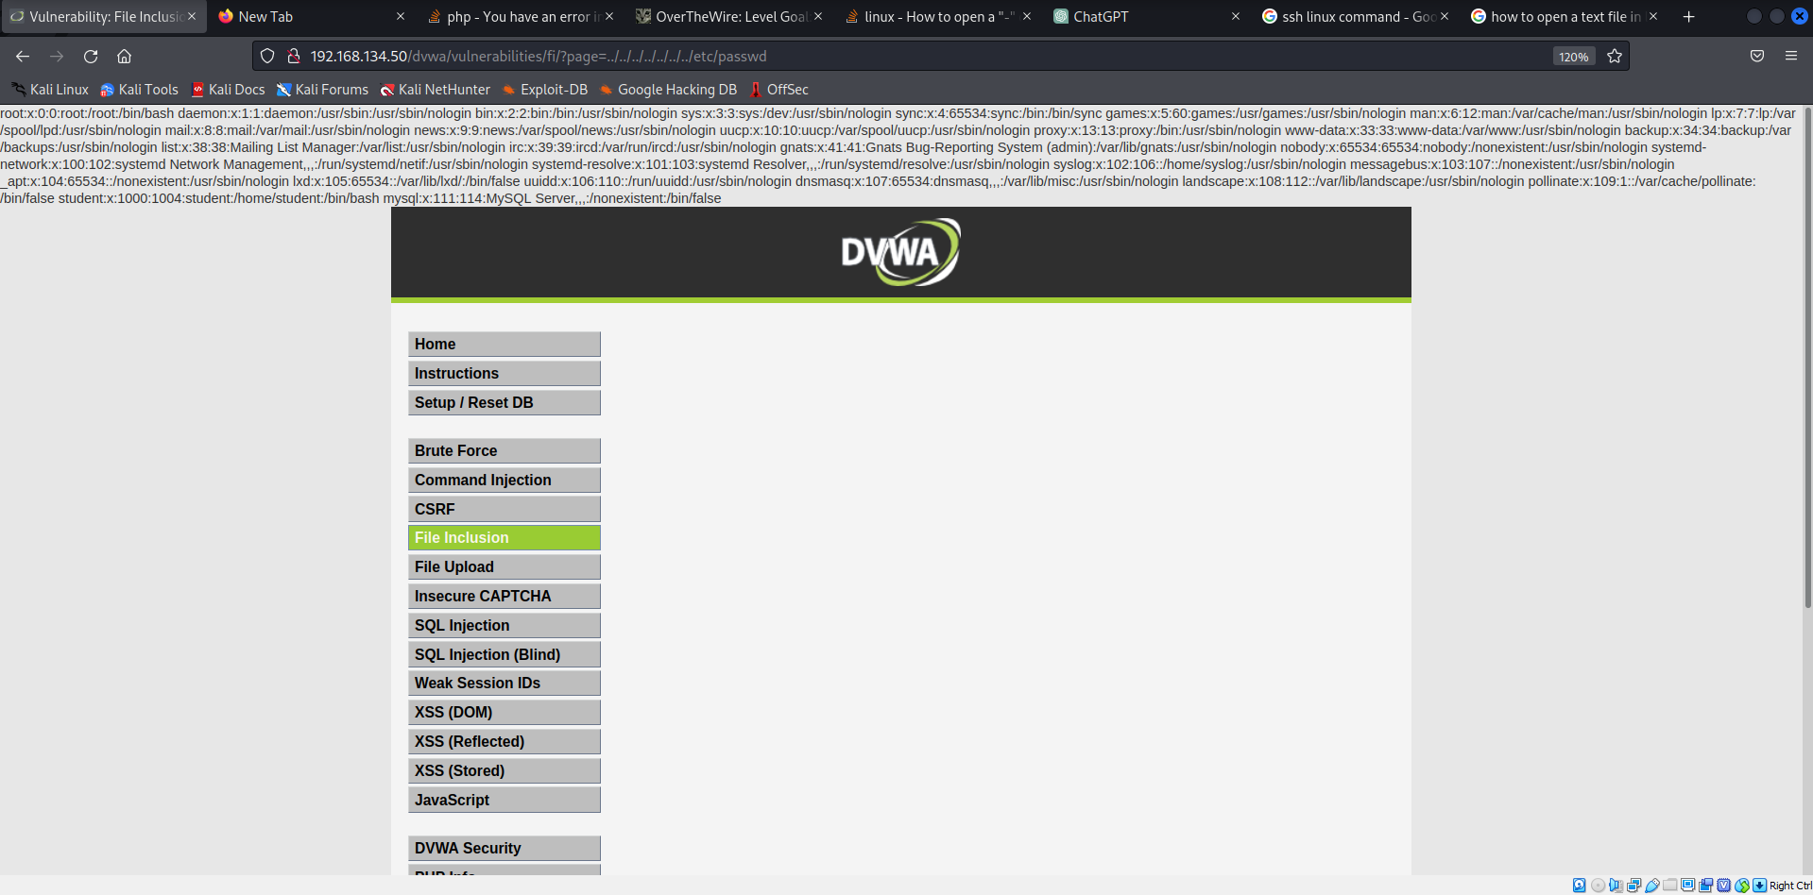

One of the exercises I started doing lately is those of Portswigger.

The exercises are in the form of lab experiments on an existing page with vulnerabilities.

I did many examples with different scenarios, protections, and common ways of breakthrough. Also, I learned a good way to prevent a path traversal attack, which I haven’t paid attention to so far when developing websites and it was to validate the canonical path of a file based on user input.

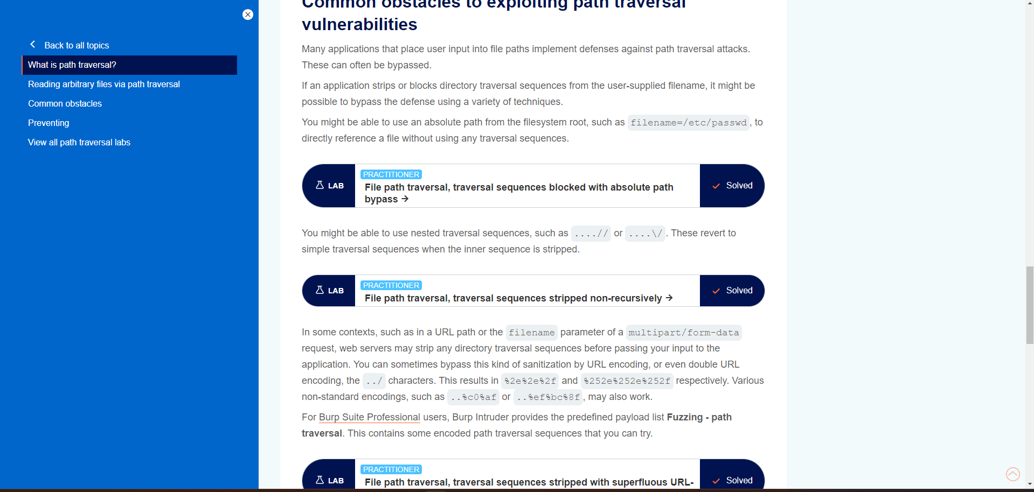

Shell injection, or command injection allows the attacker to execute OS commands on the server, running the application.

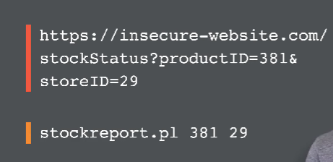

In this example to provide the stock information, the app must query various legacy systems, so it calls a shell command to get this information.

That’s where the command injection is done by adding other commands alongside the example.

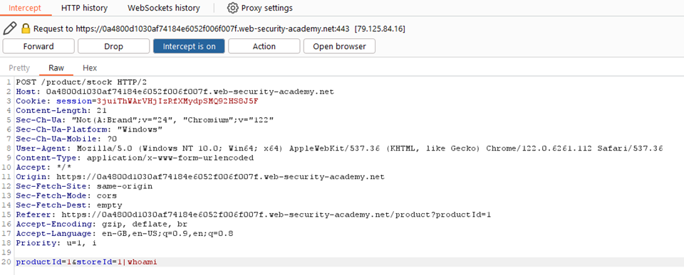

By adding “| whoami” to the storeId I insert a function to determine the name of the current user.

* 1. XSS & CSRF

Cross-site scripting (XSS)

Cross-site scripting (XSS) is similar to command injection, but this time we are injecting a script instead of a command.  84% of all security vulnerabilities documented by [Symantec](https://en.wikipedia.org/wiki/Symantec) are of Cross-site scripting as of 2007. (source: [WikipediaLinks to an external site.](https://en.wikipedia.org/wiki/Cross-site_scripting))

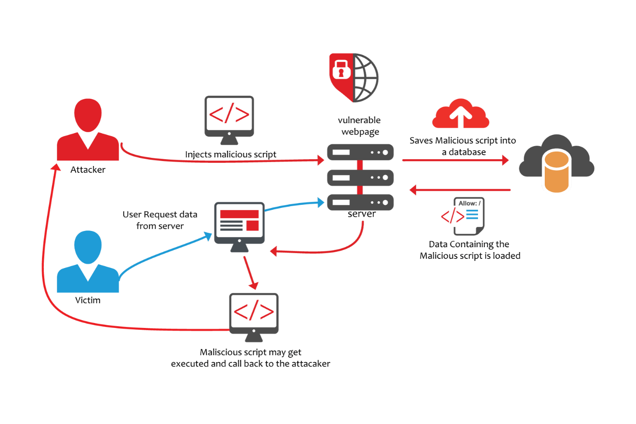

Figure: Simple persistent XSS-attack (image source [*https://www.acunetix.com/)Links to an external site.*](https://www.acunetix.com/))

An example of XSS is the following command: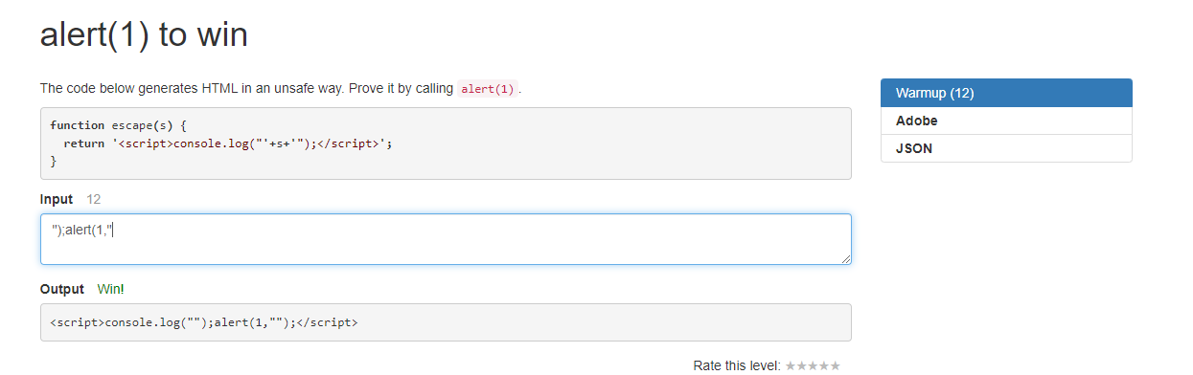

In this case, the function returns a script, which logs the variable “s” which is the value of the input field. By concatenating the variable with parentheses the application can output what I wrote like a quotation, but if we intercept it by passing "); alert(1," to it, we are running

**return '**<script>console.log("**'+**");alert(1," **+'**");</script>**';**

This logs an empty string and runs a second command that alerts the user “1” in a pop-up format in the browser, which is the challenge of this level.

The difference between Persistent and Non-Persistent XSS is that a Persistent one is executed constantly when triggering an action, whereas Non-Persistent XSS is used to trick the console to run it on the go.

Defending Against Non-Persistent XSS is necessary on both the server side and the user site.

Server-side protection is making sure the web application does not make use of user input in the return HTML pages, without validating it first. In case the validation functions find script tags, either in plain text or encoded, they should sanitize the input before it is passed on to the response HTML and make sure that the script is rendered harmless.

User-side advice is always to be weary of what they click on; avoid playing seemingly harmless games, claiming random prizes, or opening emails that don’t come from a trusted source. At the same time, users should avoid installing browser plugins that do not have a good reputation and those that are not a necessity (such as toolbars), since these may make their browser vulnerable too. Also using an up-to-date browser is essential for protection against it. (source <https://www.acunetix.com/blog/articles/non-persistent-xss/>)

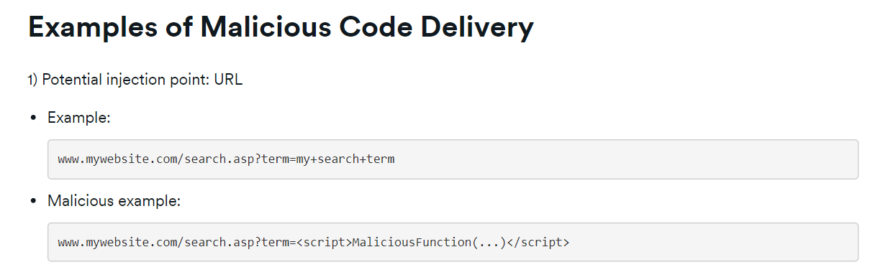

Cross-Site Request Forgery(CRSF)

Cross-Site Request Forgery (CSRF) is an attack that forces an end user to execute unwanted actions on a web application in which they’re currently authenticated. With a little help of social engineering (such as sending a link via email or chat), an attacker may trick the users of a web application into executing actions of the attacker’s choosing. If the victim is a normal user, a successful CSRF attack can force the user to perform state-changing requests like transferring funds, changing their email address, and so forth. If the victim is an administrative account, CSRF can compromise the entire web application. (source: <https://owasp.org/www-community/attacks/xss/>)

For example, we have a field for changing the password and a second one to confirm it. If we press submit and the passwords match, when completed, the website will produce a URL like this:

As you can see, the new password is publicly shown in the URL, permitting whoever has this link to change the password to something else and make the person click it as a form of phishing. In this file, the link “Fifa 2023” has the HTML tag <a with the upper link.

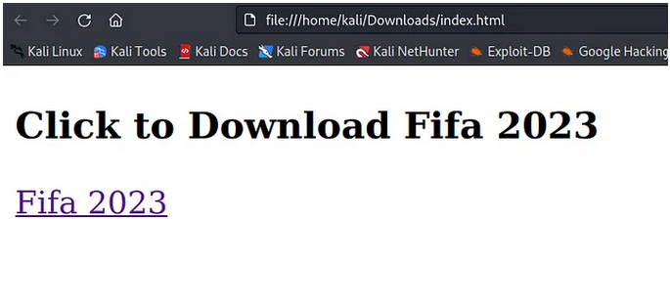

Now I will change it to “administrator” and I will click the link:



And the login is incorrect because we have changed the password:

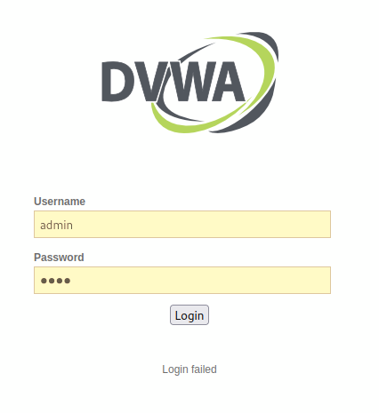

* 1. Network Scanning and Enumeration (incl. Sniffing)

Scanning a network gives more insight into what the network environment looks like. For the basic exercise level for Network Scanning, I had to set up 2 more Virtual Machines and PfSense. I installed one more Kali Linux machine and a Windows one. Then I assigned them a common VLAN, but at this point, they didn’t have their IPs yet. That’s why I used Pfsense as a firewall to be a mediator between my private VLAN and the DHCP network.

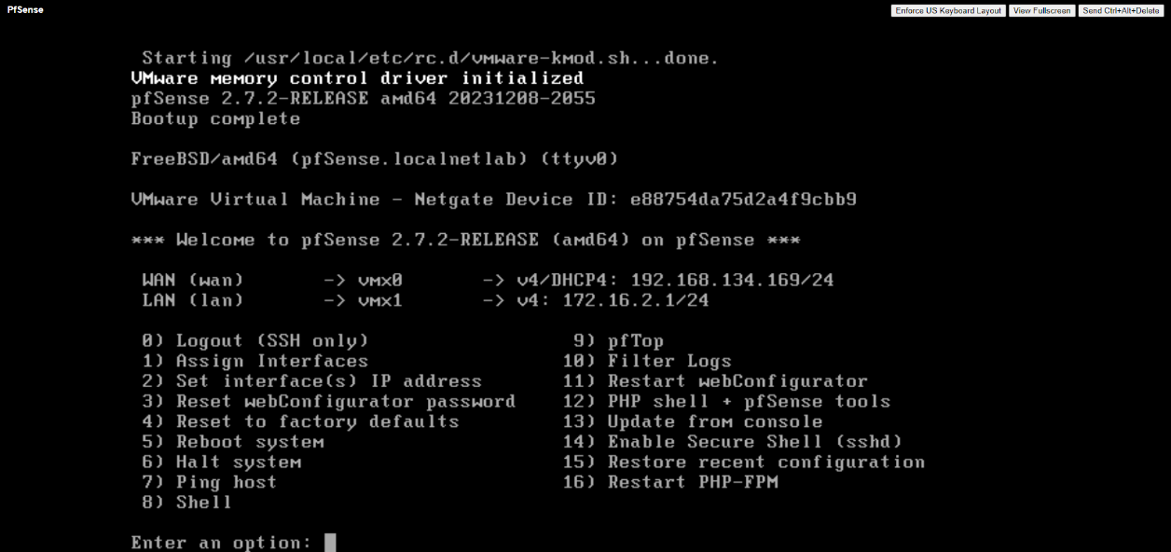

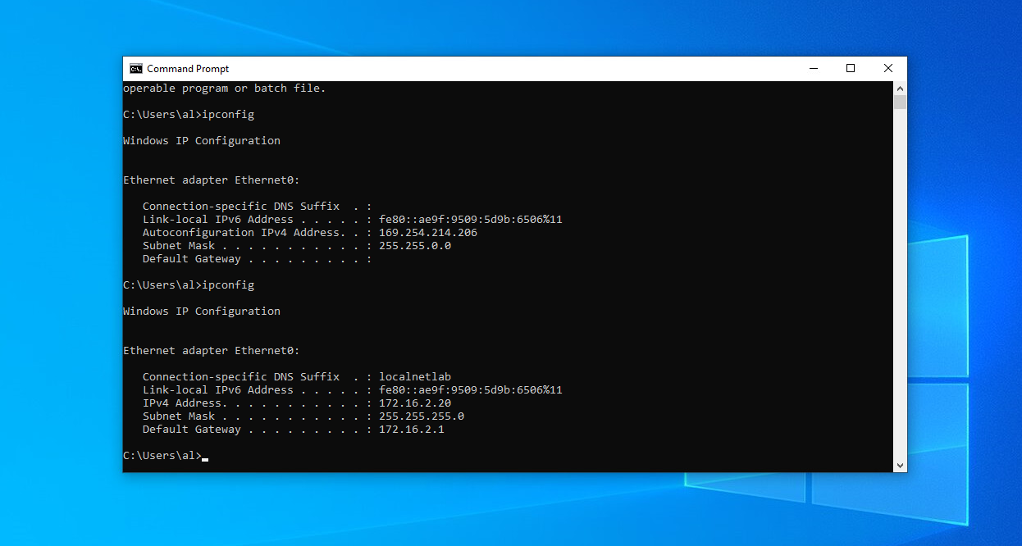

As you can see in the image above there are two states of the ethernet adapter. One doesn’t have a default gateway and the other has it as 172.16.2.1 and a DNS Suffix localnetlab.

Then I was able to scan my network in different ways in Kali Linux.

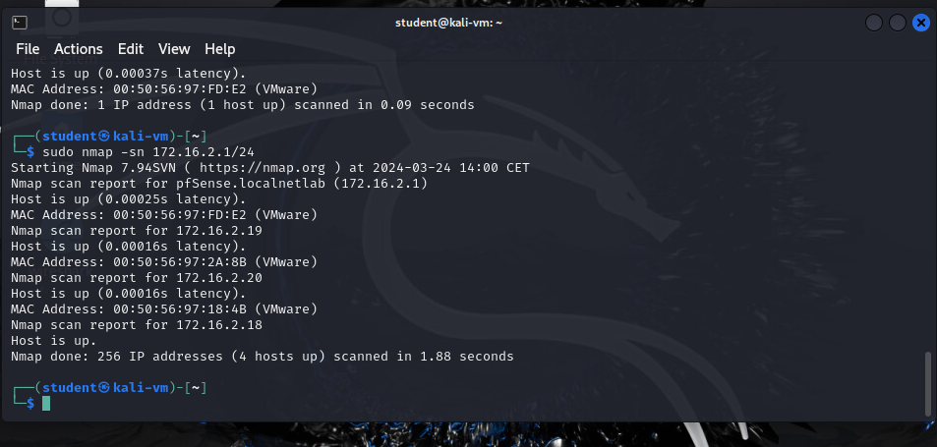

As you can see there are 4 devices found in this network as expected.

The next scan is based on looking for the operating system of the machines:

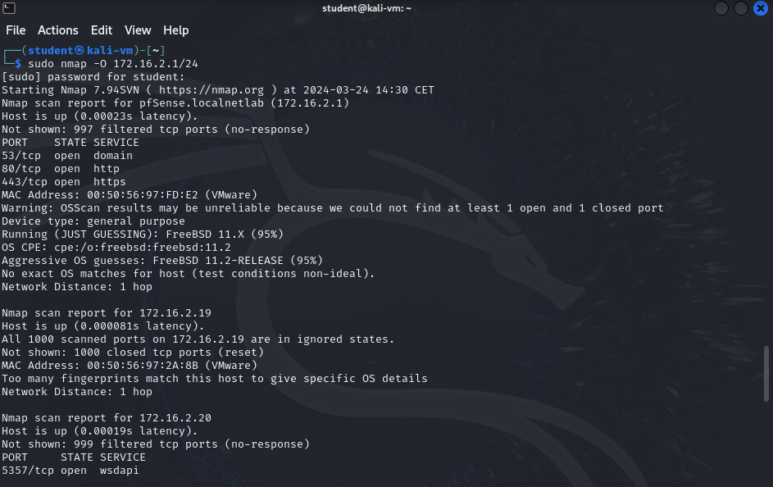

Usually by scanning like this, we might trigger the firewall protection of the endpoint, which may cause some problems, so a more discrete way of scanning would be with the -sS parameter, where S stands for Stealth:

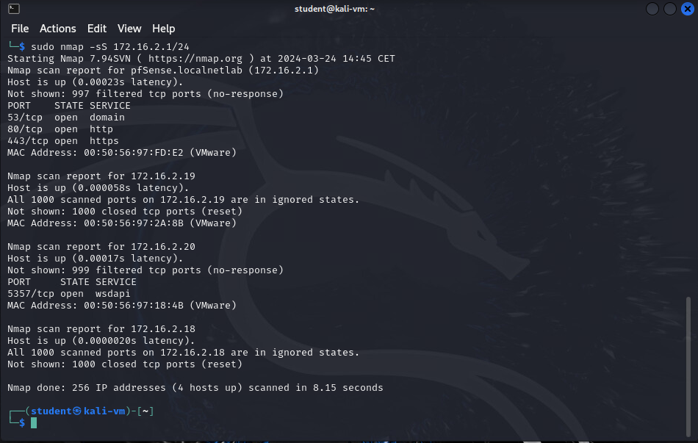

To port a host we have to nmap again. By this method, we can check if the port is open and if any servers are running from this port. I am scanning a dummy host right now.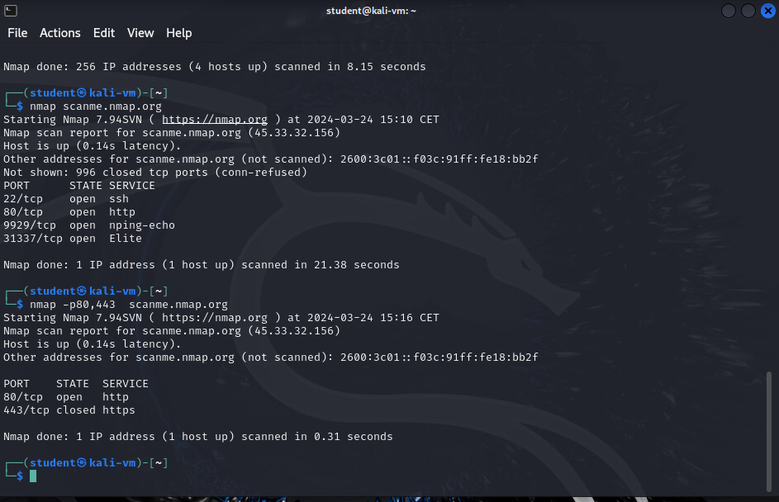

To be able to access the SSH console of another machine we have to install the SSH server to the target machine. In my second Kali Linux, I installed SSH and by default, a port is open on 22.

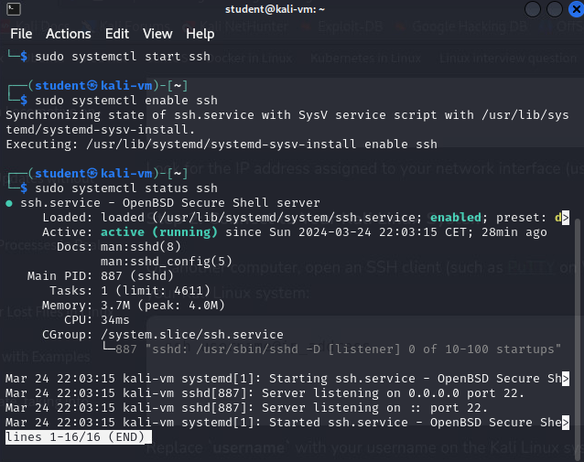

To remotely access this machine, we need to go to the first one and SSH it by writing SSH 172.16.2.19, which will give us the option to write the password for the second user and to use its SSH terminal giving us access to manipulate it.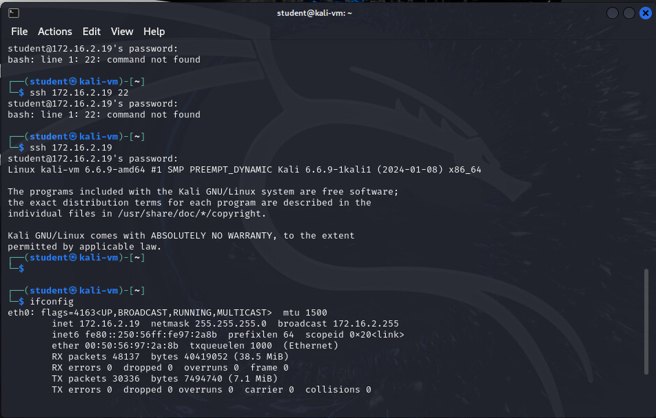

After login, I check with the IP to see if it has changed since the name of my machines is identical. As you can see the last two digits are 19, which are assigned indeed to the second Kali Linux machine, meaning that we are inside it.

* 1. Network Separation and Segmentation

Network Separation and segmentation means to divide a network into smaller parts, to have more controlled and secured network layers. By doing this, we have more control over how traffic moves among the different sections of the network.

For example, imagine a big company with different departments – financial, logistics, HR, etc.

In this case, every network of those departments is isolated from the other and thus the systems will work better for the employees using it.

For exercise, I had to set up a secure Network segmentation involving at least one web server, one or more firewalls and/or routers, a Management Server (Active Directory / Domain Controller), workstation.

I used an online network diagram tool (smartdraw.com) to plan my network configuration:

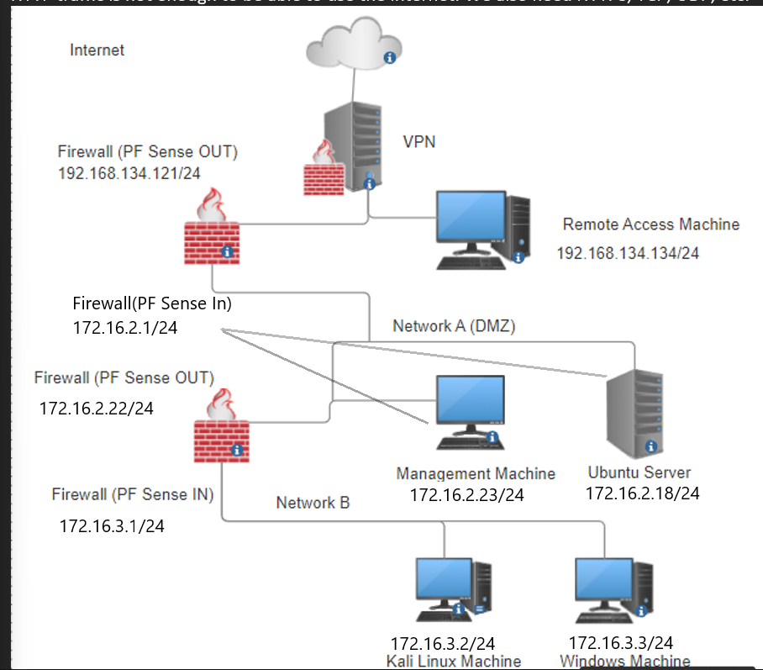

So I set up a Kali Linux machine (172.16.3.2)and a Windows machine (172.16.3.3)which are in vLanB be protected by the second Firewall(172.16.3.1) The demilitarized Zone with public access I have put in vLanA with the management machine. Both User Lan and DMZ have different DHCP and IP ranges. I have set the server’s IP address to be static, to be always findable by other machines.

The challenges I encountered emerged when I tried to understand how I could access the second firewall’s interface from the machines in vLanB. The problem was in the beginning when I made both firewalls the same IP address. After discussing it with my coach, I understood that this cannot be, because both routers can send information up and downwards. Then I make network B in a different network 172.16.3.x.

In addition, I have created basic firewall filtering based on aliases. Incoming and outbound network packets are allowed or blocked based on their origin (IP address, internal /

external network) and service/protocol (TCP / UDP port number).

//todo DNS rules

VPN: How to manage a Web Shop with Secure Remote Access

A virtual private network (VPN) gives access to a private network across a public one and permits users to send and receive data as if they are currently located in the local network.

It is used widely across companies, that need their employees to benefit from the functionality, security, and management of the private network. 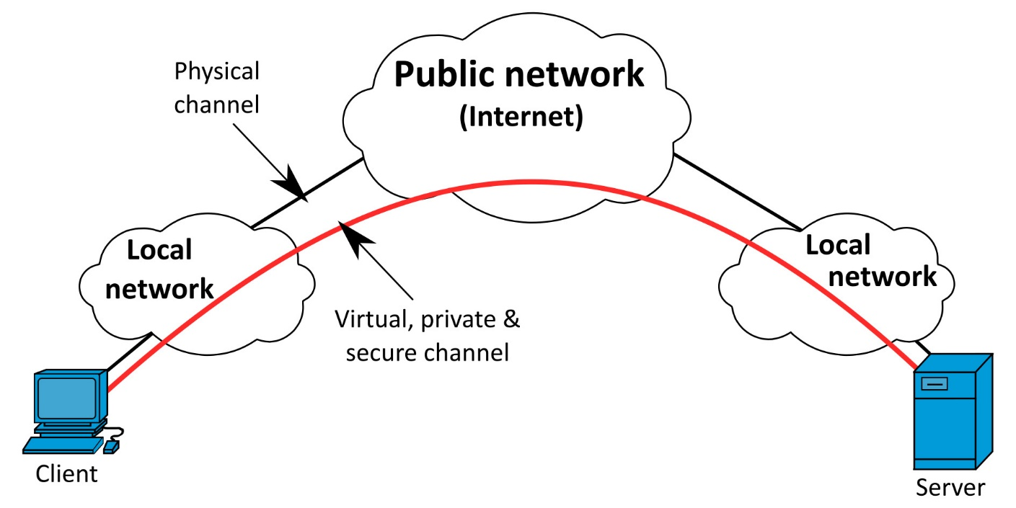

As you can see in the picture above, the client “skips” all the networks that are in between him/her and the server. This can happen in our case when we install a VPN service and authorize clients to have access through certificates, usernames/passwords, or signatures. It uses the OpenSSL encryption library extensively, as well as the TLS protocol, and contains many security and control features.

We will use OpenVPN for the exercise. It was written by James Yonan and is free software, released under the terms of the GNU General Public License version 2 (GPLv2). First, we need to create a new certificate authority:

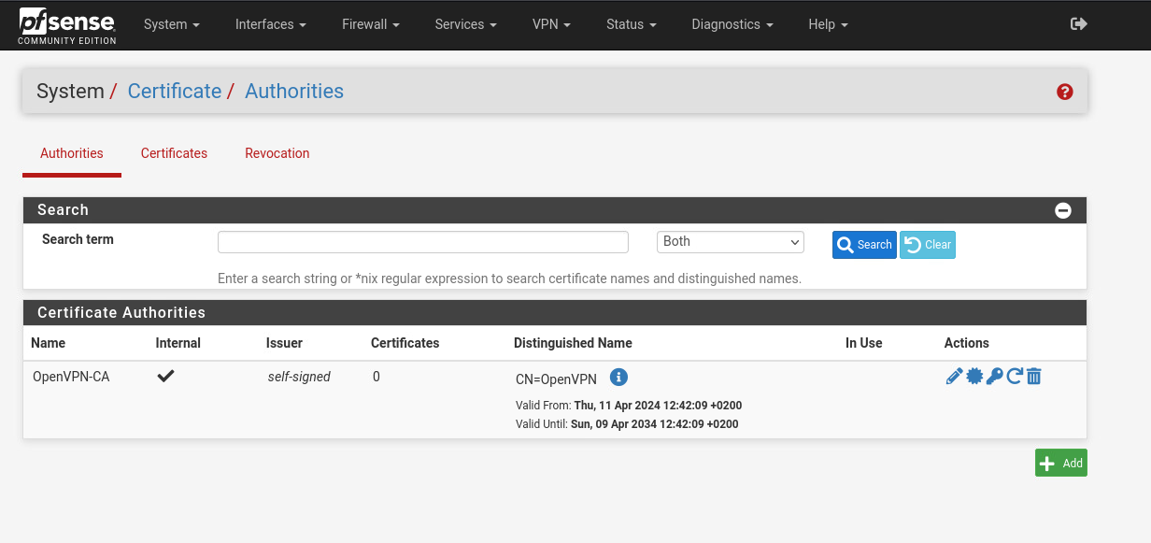

Then we also need to create a server certificate. We navigate to certificates and create one:

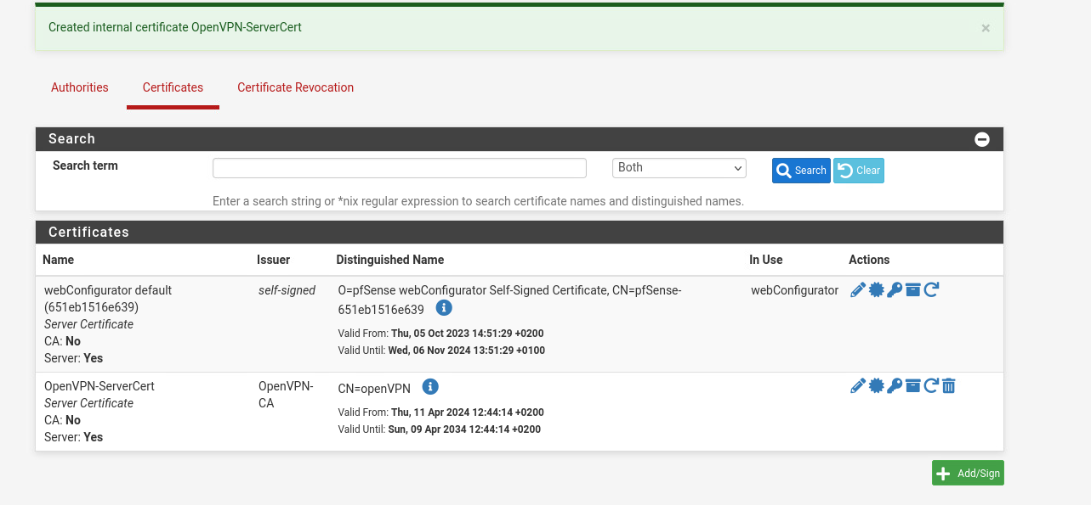

It has the name OpenVPN-ServerCert. The next step is to go to the user manager and create a user that will access the VPN:

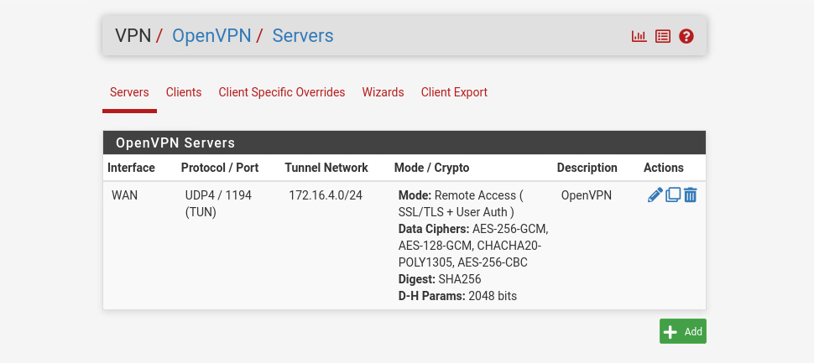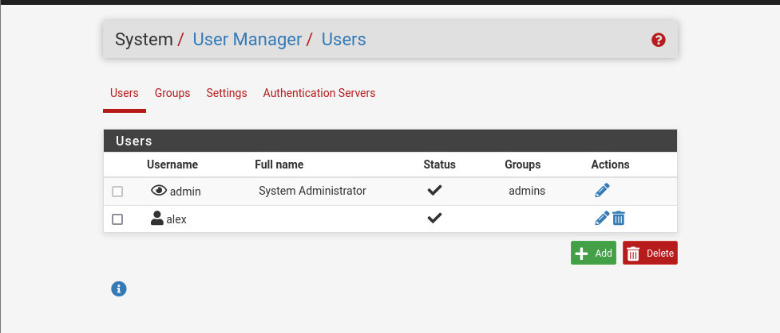

Then we need to install the OpenVPN package export in System/Package Manager and search for OpenVPN.

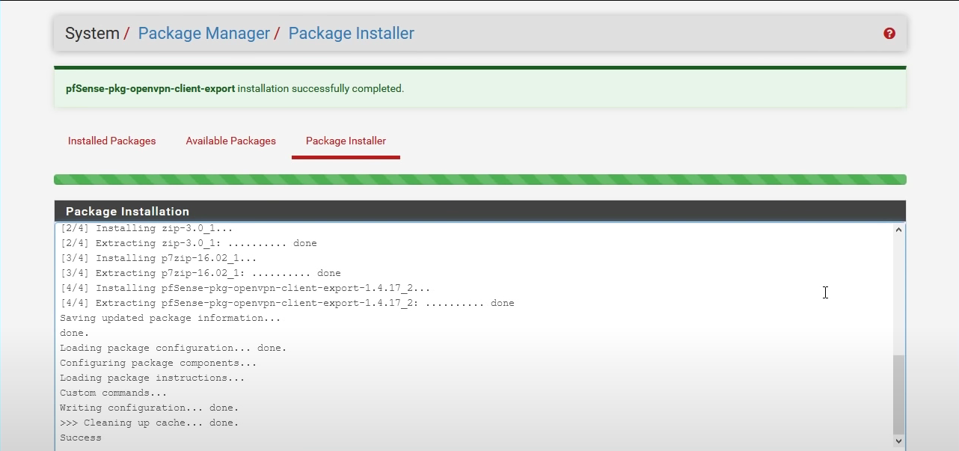

Now we need to enable it through VPN/OpenVPN/Wizard.

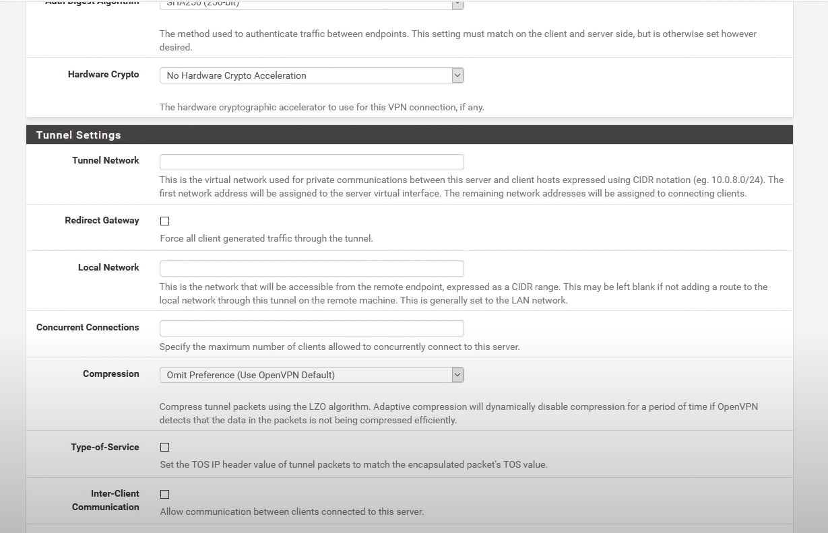

It is very important to add the local network as 192.168.134.0/24 with .0, otherwise, there will be a bug in the system. In the tunnel network, we put the virtual private network. We also need to activate Redirect Gateway to force all traffic through this tunnel and if we have more than one user it is a good idea to activate Inter-Client Communication, but in our case, we leave it empty. The DNS domain we can wee in PfSense’s System/General Setup – Domain.

We also add a rule to permit connections through the firewall and the traffic from clients through the VPN. 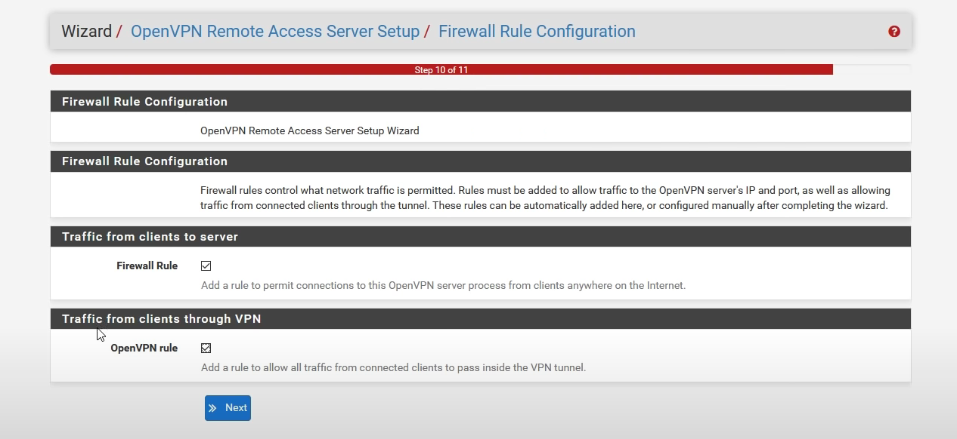

At this point, we have set up the VPN successfully. One more step before we connect is to go to Client Export Utility and set it up. At the bottom of the page, there is a list of URLs to install OpenVPN depending on our operating system. In our case, it is Kali Linux.

//to upload a screenshot

* 1. WiFi Hacking

For this topic, I got my external wifi card called Ralink. I needed this to try some wifi sniffing, which Is a term that describes the action of gaining detailed information about the packets transferred through a wifi network.

The first step to do this is to enable the card in my virtual machine. Then we can run the command “sudo airmon-ng” in. This script can be used to enable monitor mode on wireless interfaces. It may also be used to kill network managers or go back from monitor mode to managed mode.

When running “sudo airmon-ng start XXXX”, where XXXX is the desired interface, in our case wlan0 we say that we want to put the specific interface it in monitor mode.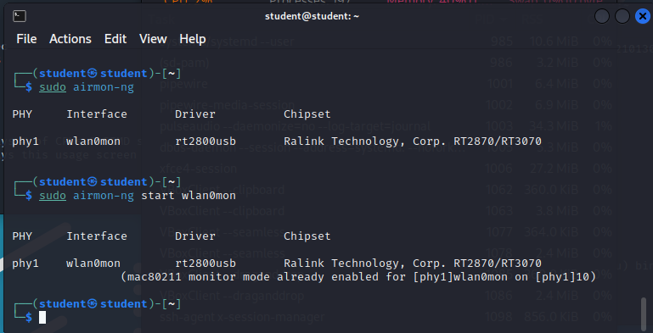



Now we can see that after wlan0 there is “mon”, which means that it is monitoring the connection.

After that, we type “sudo airodump-ng wlan0mon”:

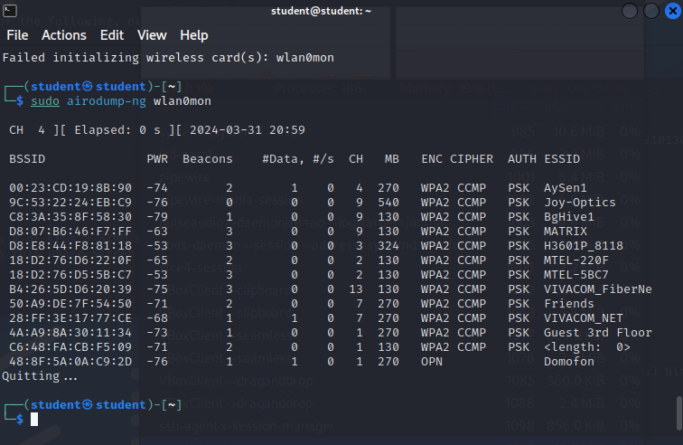

And what it is doing up here on the top left corner, which is known as channel hopping, is going from one channel to another, displaying them. In this case, I can find my network here:



Once we have this information, we can step one step further and target our network specifically. Now let's run “airodump -c2 -w Capture -d xxx wlan0mon”, where xxx is where we associate our access point in our case the first column of the image above. It should look like this:



Now we can see our network:

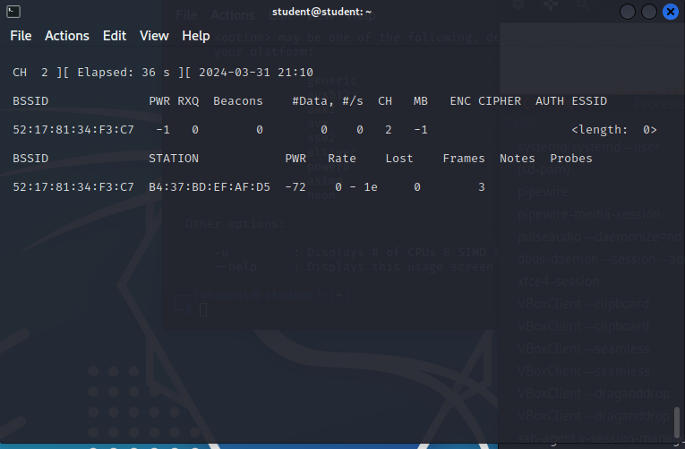

Now we can do a de-authentication attack to get the four-way handshake, which is a type of network authentication protocol that allows an authenticator and a wireless client to establish an encrypted connection without having to reveal the passkey:

--deauth deauthenticates unlimited times(0) a station (-a), which is another device of mine on an access point (-c, client):



Just to make the process a little bit faster, on my device I will continuously connect and disconnect to be able to capture it. The terminal will start displaying sending packages like this. 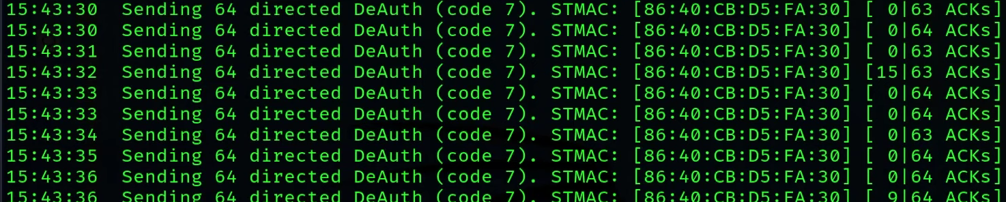

And if successful the handshake should be displayed at the top right of the terminal after some time:

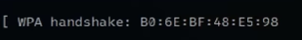

Then after doing ls to see what types of files we have captured, we can see that we have plenty including Capture. cap, Capture.csv, and Capture.kismet.cs, Password.txt, etc, where the most important one is the first file. We can use this file to display in Wireshark what the handshake includes, but for now, we will only run wc password.txt, which may look like this:

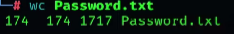

174 means that it is only 174 words.

Now we can use aircrack-ng, which cracks the password, by using the .cap file and a wordlist file that we need to provide everything is successful it should look like this:

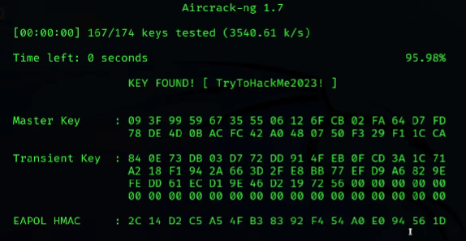

* 1. Password Cracking (system and network)

Password cracking is the process of trying to get a password through various methods and/or combinations of them. The most common method for obtaining unauthorized access to a password is to repeatedly try to log in using different usernames and password combinations until eventually, one attempt is successful, SQL injections give sensitive data including passwords.

The used strategies are similar:

A dictionary attack is trying very common passwords. A brute force attack is a technique used in computer science to try a large number of possibilities, such as passwords or keys, to find the correct one. It involves trying every possible

combination until the correct one is found. We will use Burp Suite and Hydra to brute force the login form provided by DVWA.

In this challenge, we will test a password list against the user and

try to log in as the target user Hybrid attack is a combination of both strategies mentioned above.  
Usually, the passwords are stored in a database as a string of hashed characters, making it unreadable to the viewer.

A common mistake people make is to set a default username and password combinations for their devices, not limit the number of login attempts, weak passwords, or even such that are leaked from hacked databases in the past, through phishing, vishing, and other possible issues from keyloggers, etc.

In this exercise, I used DVWA’s brute force section to try out some password cracking. In a nutshell, this time we have to give the cracking program a list of passwords to try to make many login attempts and filter those with different feedback. For example, when a password is incorrect, a comment under the login form will show that the username/password is incorrect. We want to get the password, by which this feedback is different, which will mean that the login is successful. 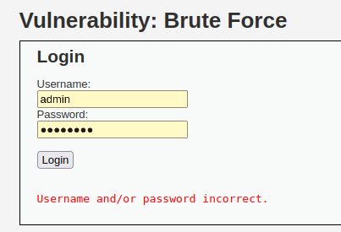

We will use Burp Suite and Hydra in this case, but there are alternatives to password cracking such as wfuzz and the ripper tools which I will try out soon.

The first step is to submit a request from the Firefox browser of Burpsuite to log in with the wrong credentials. The complete request will be shown in the burp. Then we send it to the intruder module and we clear all targets locate the password field and add it as a target.

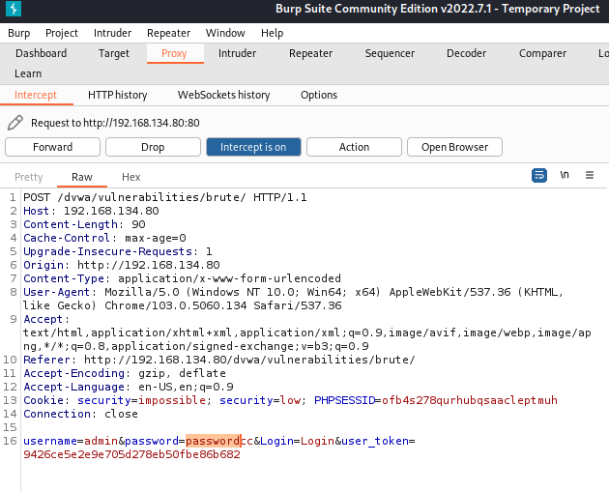Then we add the list: 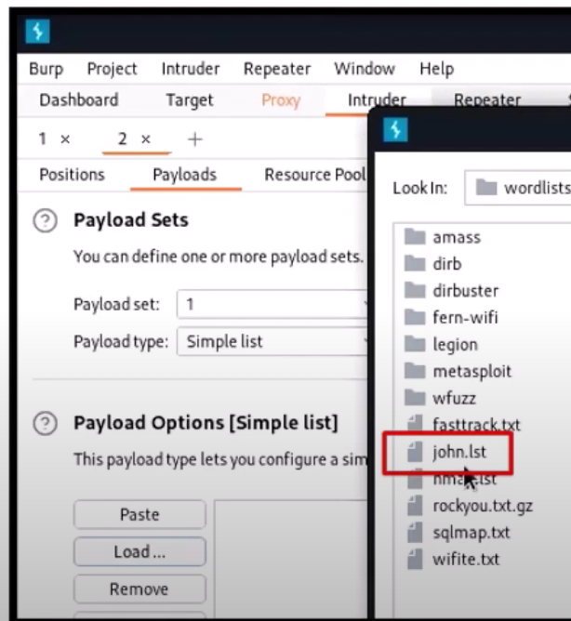and we start the attack. Where we see a change in the length it should be the thing we are searching for.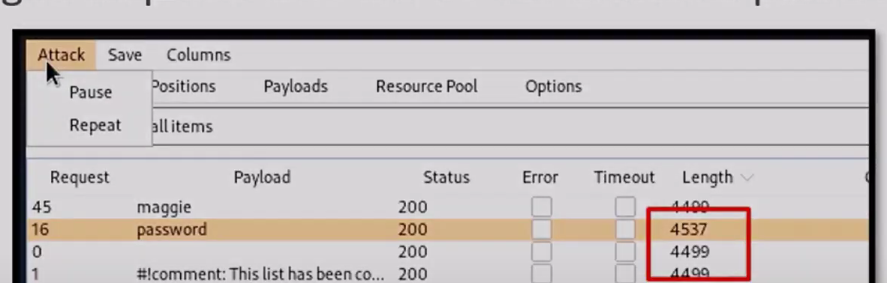

With Hydra, we need to use the terminal. There we type the details manually. It performs different types of attacks such as HTTP, FTP, Telnet, and SSH. It can brute force passwords much faster than Burp Suite. The details we need to provide are the complete URL of the form and replace the user with “^USER” and the password with “^PASS” respectively. We also need the cookie information from the storage tab in debug men. Lastly, we need to set the login failure information with the F flag. 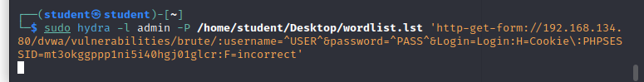I’m still in the process of understanding the syntax, for now, I have errors: 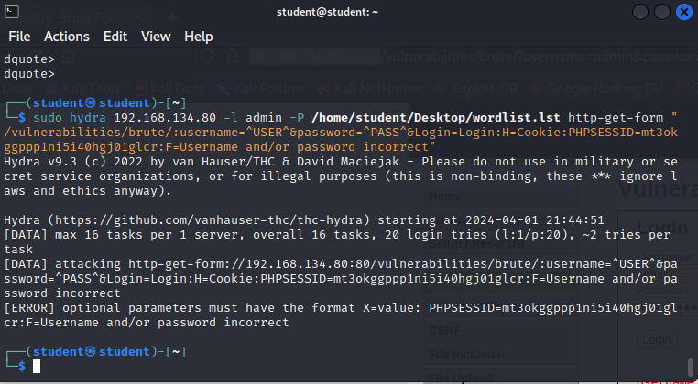but it should be displayed like this: 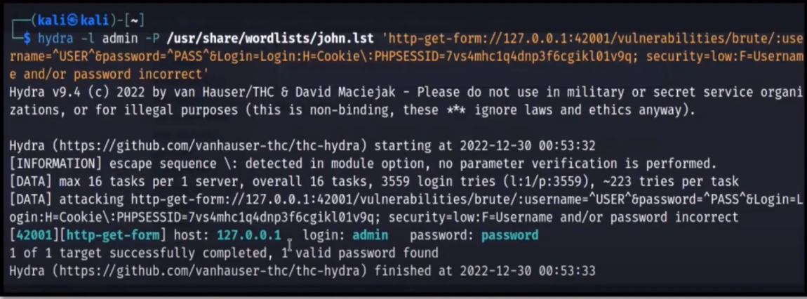

# BoK Additional

The "BoK Additonal" phase runs from weeks 7 to 12 and deals with topics of choice, at least 6, see Canvas.

<mention your personal choices here and create a subsection per topic>

* 1. WAF (Web Application Firewall)

Web Application Firewall is a layer that helps protect web apps from attacks such as cross-site scripting (XSS), file inclusion, SQL injection, and cross-site forgery by monitoring and filtering HTTP traffic between a web application and the internet. It is a type of reverse proxy, that protects the server from exposure by having clients pass through the WAF before reaching the server.

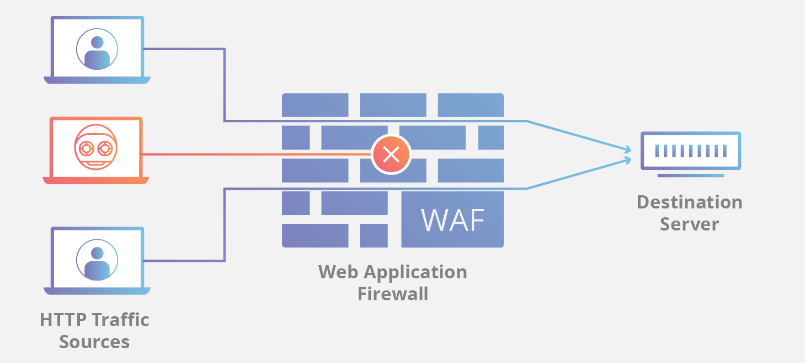

A WAF can be implemented in one of three different ways, each with its benefits and shortcomings:

* A network-based WAF is generally hardware-based. Since they are installed locally, they minimize latency, but network-based WAFs are the most expensive option and require the storage and maintenance of physical equipment.
* A host-based WAF may be fully integrated into an application’s software. This solution is less expensive than a network-based WAF and offers more customizability. The downside of a host-based WAF is the consumption of local server resources, implementation complexity, and maintenance costs. These components typically require engineering time and may be costly.

Cloud-based WAFs offer an affordable option that is very easy to implement; they usually offer a turnkey installation that is as simple as a change in DNS to redirect traffic. Cloud-based WAFs also have a minimal upfront cost, as users pay monthly or annually for security as a service. Cloud-based WAFs can also offer a solution that is consistently updated to protect against the newest threats without any additional work or cost on the user’s end. The drawback of a cloud-based WAF is that users hand over the responsibility to a third party, therefore some features of the WAF may be a black box to them. (A cloud-based WAF is one type of cloud firewall)

Source: <https://www.cloudflare.com/learning/ddos/glossary/web-application-firewall-waf/>

For this topic, I will install ModSecurity WAF on the DVWA machine.

There is a pdf file from Canvas, which I followed to install it. There is a step-by-step guide on how to download it, enable the Apache 2 headers module, and configure ModSecurity to detect logs, and block suspicious activities. Then download the latest OWASP ModSecurity Core Rule Set from the GitHub page.

Eventually, when doing any kind of attack it should be blocked by the firewall like this:

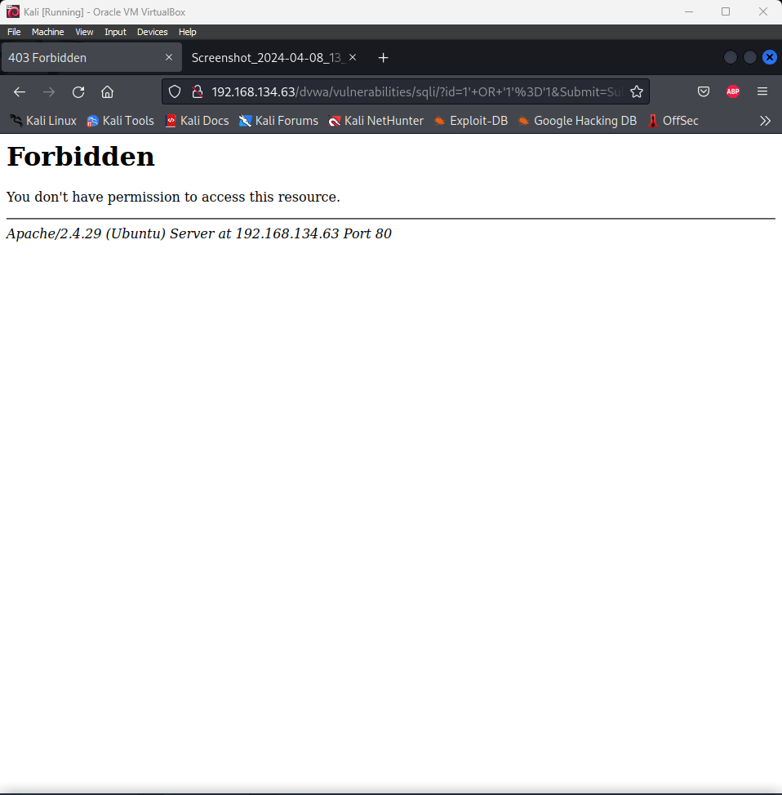

* 1. Host Intrusion Detection and Prevention (HIDS)

Host-based intrusion detection is a type of tool that Detects and optionally prevents threats and attacks on a server. It is similar to network intrusion detection, but it is hosted on a dedicated machine instead of the network, and “agents” are usually installed on the endpoints to monitor the tasks.

A Network-based Intrusion Detection System [NIDS] is a security solution designed to monitor & analyze network traffic for potential security breaches or malicious activities. It operates as a passive monitoring system, observing data packets passing through the network in real-time. NIDS helps identify & respond to various cyber threats, such as malware, unauthorized access attempts & suspicious patterns, to enhance overall network security.

NIDS inspects network packets using various techniques like signature-based & anomaly-based detection. It examines packet headers & payloads, comparing them against a database of known attack signatures. If a match is found, it raises an alert. Anomaly-based detection identifies deviations from normal network behavior, flagging any unusual activities that might indicate a potential intrusion. NIDS can also prevent attacks by blocking malicious traffic or sending alerts to administrators.

One drawback of this type of intrusion detection is that, with HIDS only, no overview of what is going on in the network is present.

To get in touch with such software, I installed Wazuh’s indexer, manager, server, and agent to see a dashboard of what is visible, concerning security events. For me this process was a hard one, it took me a considerable amount of time to grasp the idea of the software and its components. I decided to do an all-in-one install on my Ubuntu desktop VM and install an agent on my DVWA: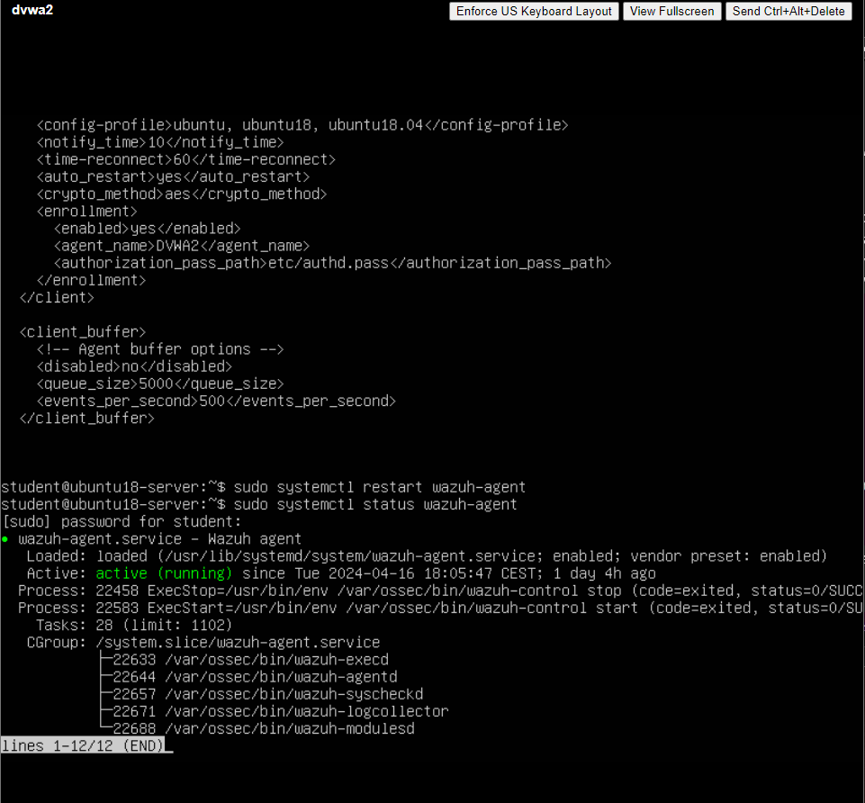

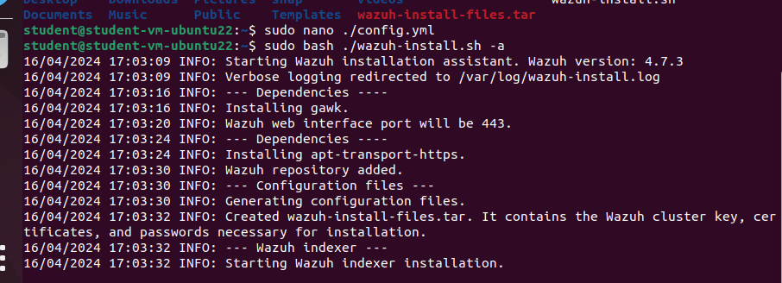

After the installation, a dashboard was accessible, by typing the IP of the server in the browser. The predefined credentials were displayed right after installation:



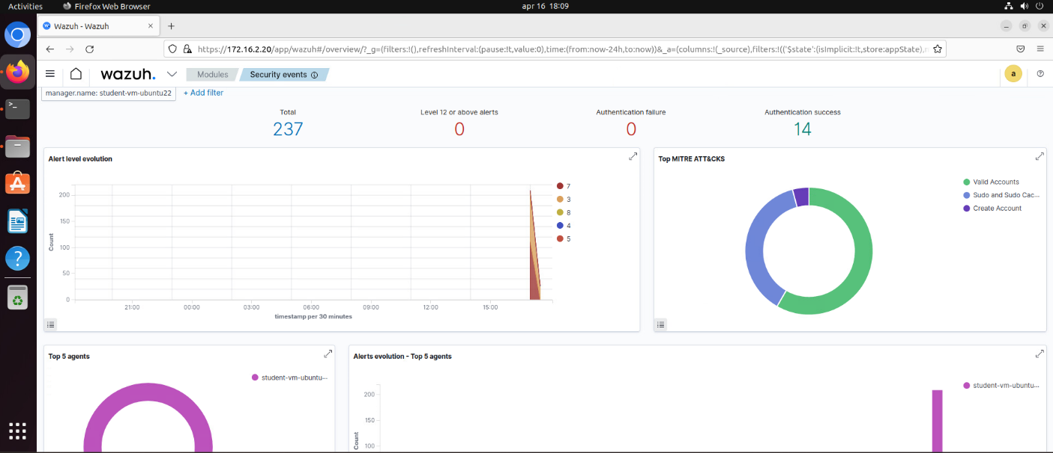

At the bottom of the page, there is a broader overview of the events of the current machine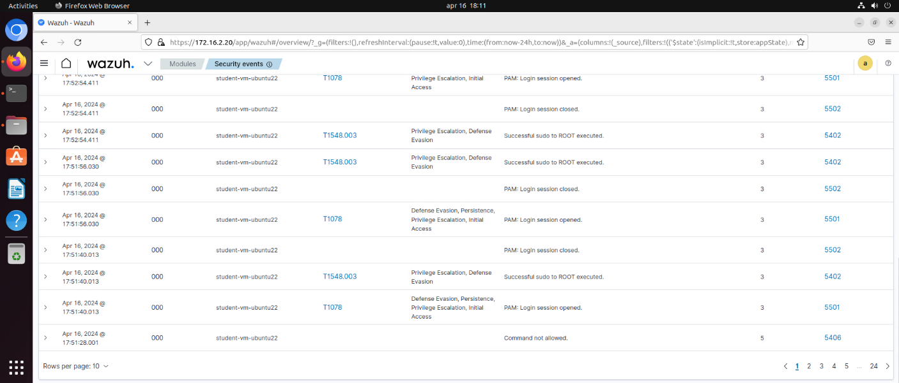

Now we install an agent to out dvwa machine and we will try to simulate an attack:

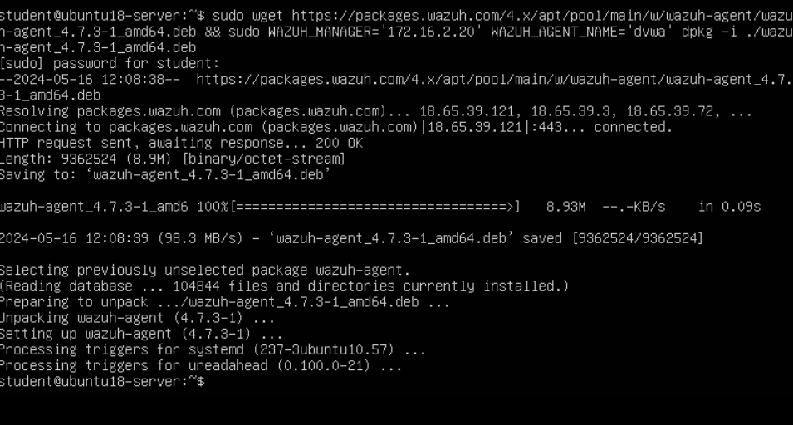

After installation, we can confirm that it is active because it shows up in the dashboard as an active agent:

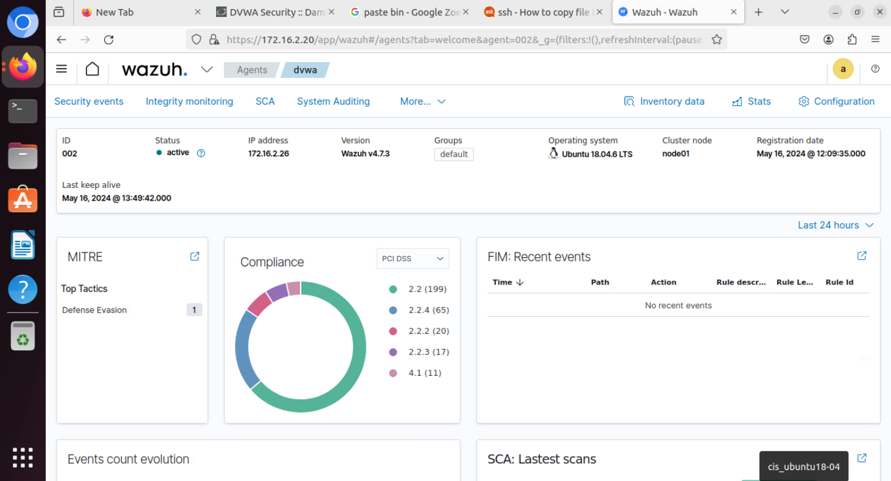

Now I will try to do a SQL injection and see if it will record it.

And as you can see it captures the moment:

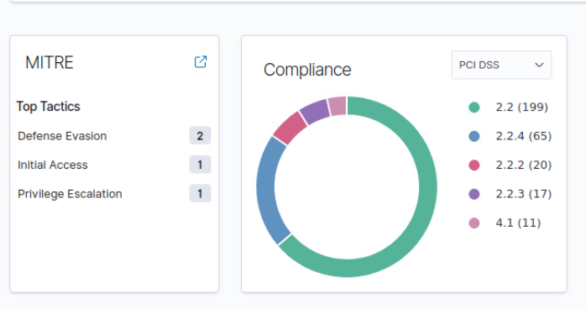

On the left you can see what exactly happened and if we zoom into the privilege Escalation you see the type of the attack:

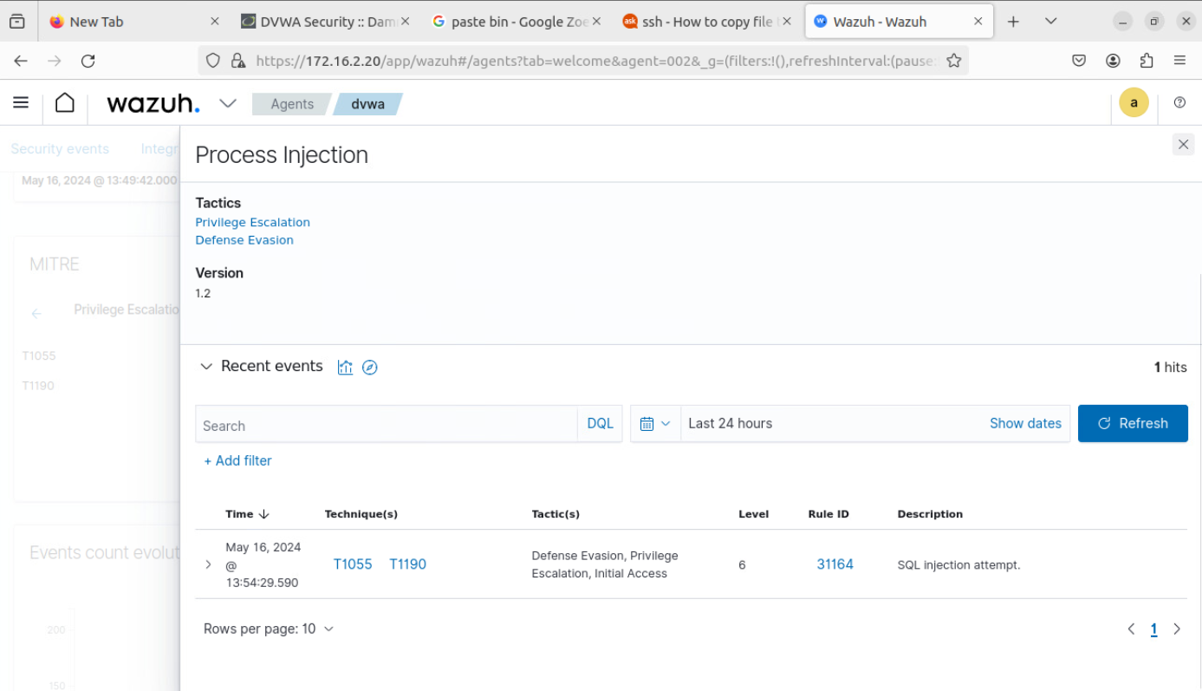

Sources: https://www.neumetric.com/hids-vs-nids/

* 1. Network Sniffing and Spoofing

Network sniffing is the process of scanning a network and seeing the ongoing traffic and the individual packets transferred. This is done by using various tools like Wireshark and Tshark.

By using network sniffers to “sniff” the packets en route, a user can analyze the traffic via “passive sniffing” (i.e., snooping in on the inflight data) or “active sniffing” (i.e., directly interacting by sending packets and receiving responses from the target devices). The latter unfortunately also allows for malicious instances.

Using encrypted protocols can help prevent unauthorized network sniffing, but since nothing is 100% guaranteed in the world of IT security, using a real-time monitoring system to alert you to any networking abnormalities is a good idea, like the one mentioned in my last topic.

Sniffing could be combined with replaying altered parts of the sniffed information, but it depends on different factors.

For example, in a switched network, which is the most common type of TCP/IP network it is impossible to sniff all network traffic because the switch will only route the traffic to the corresponding destination and not to other parties.

However, on managed switches, there is a possibility for sniffing, by defining a mirror port, which is commonly used for monitoring purposes of the network. When no mirror ports are available, we can use the so-called Spoofing.

Spoofing is pretending to be somebody else or another system. Cloning an existing website and using a similar URL, sending TCP/IP, ARP, or DNS packets with a sender address that isn’t ours, and sending an email with a form address that isn’t ours are methods considered common acts of spoofing.

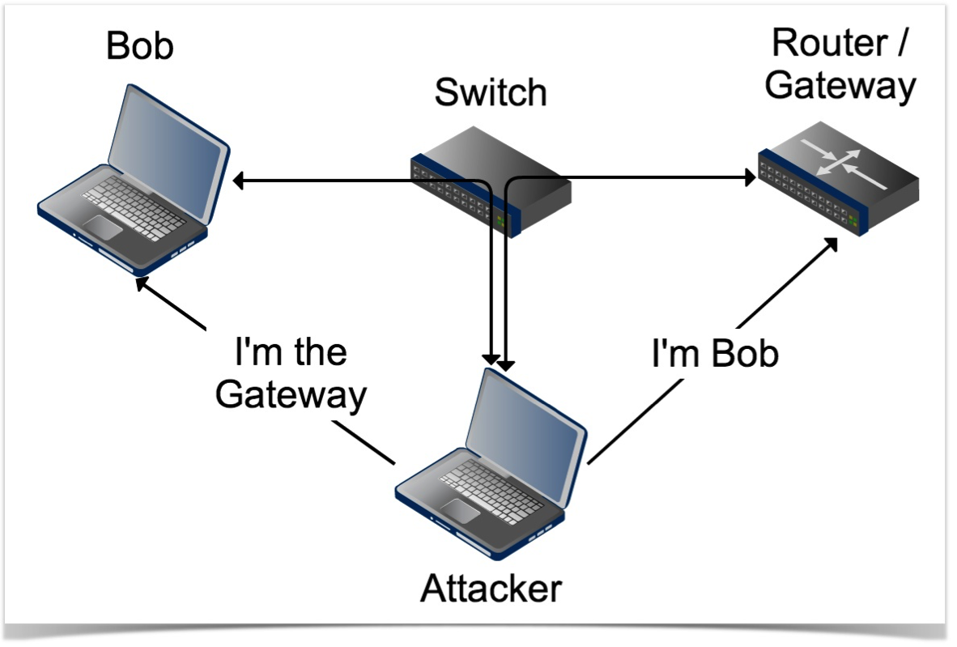

What I am going to do is capture the DVWA’s login credentials by sniffing the network when I log in 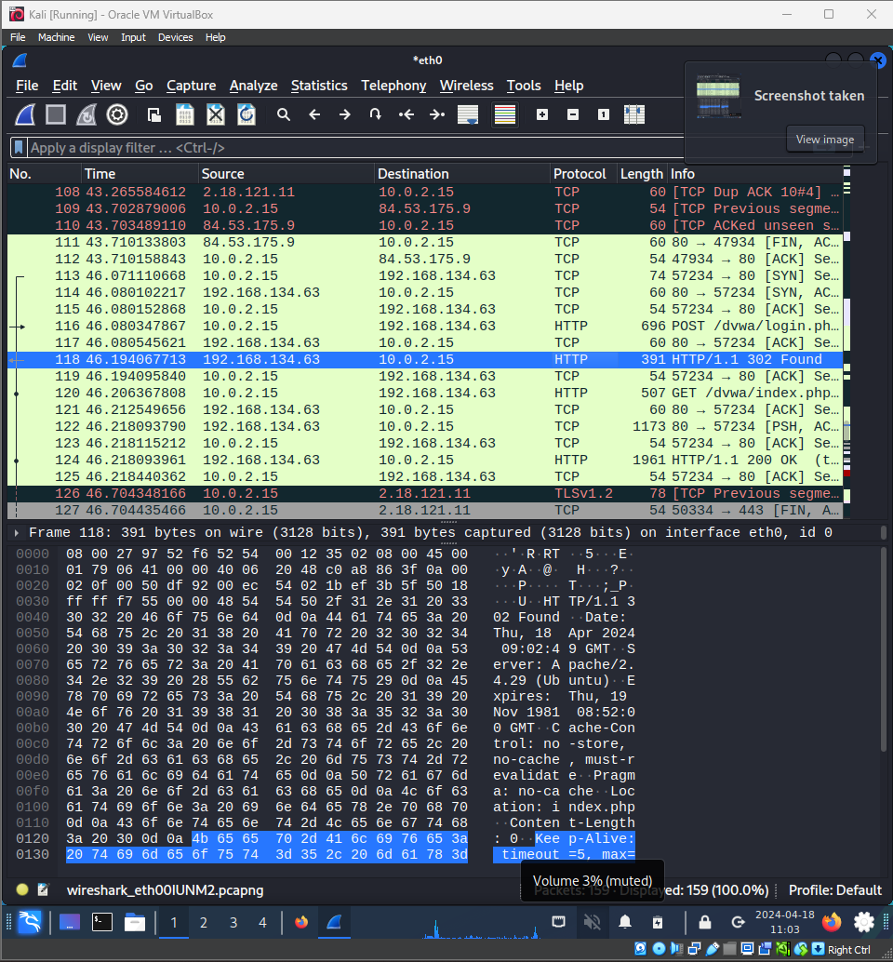

The IP of my DVWA is 192.168.134.63, so we have to look at the HTTP requests going to that domain. As you can see those requests are in green in the picture above. Scrolling through the packets we can see that the user and the password fields can be seen as the connection has not been secured.

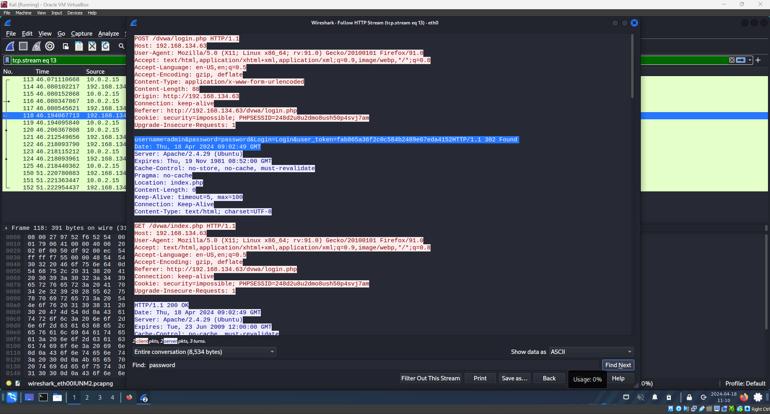

This sniffing is done on the same machine. To get more in-depth into the topic, I will perform this from a different machine.

I have set up my VLAN with 3 devices: THE DVWA, a Kali Linux machine that will log in to the system, and another Kali Linux machine that will perform the spoofing. The poisoned machine I will call Kali Sniffed and the intruder I will call Kali Sniffer.

All I have to do is open Ettercap and add two targets, one the Machine that we want to intercept and the other should be the default gateway because when logging in to the DVWA the machine sends packets to the default gateway, which then sends to the DVWA IP address. In this case, we will get those packets and see what they carry.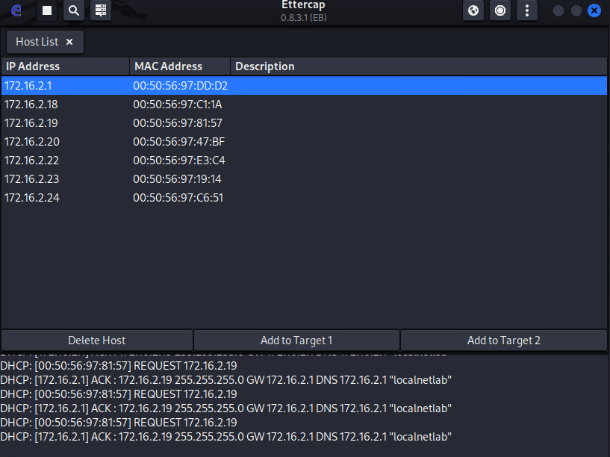

After poisoning the device, we can see that there are packets in Wireshark that are saying that there is a duplicate IP running (the default gateway), which means that our device is acting as it is.

When running traceroute 8.8.8.8 on our vulnerable device ()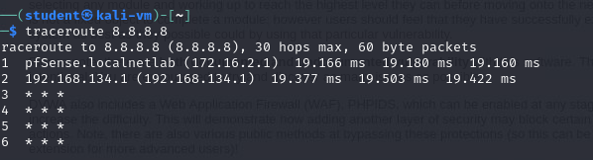

we can then see the traffic on our wireshark from the sniffer, which means that our task is done successfully.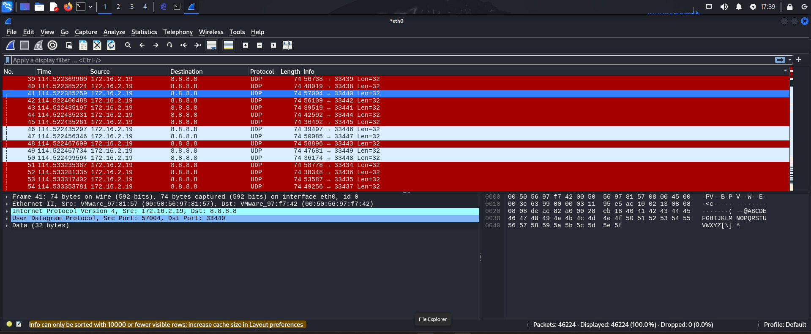

Sources: https://www.pagerduty.com/resources/learn/what-are-network-sniffers/

* 1. IT Basic Monitoring

The fundamental difference between this monitoring and the one we did with the HIDS is that now we are monitoring the performance of the resources of the device, instead of looking into the security aspect of it. For this exercise, we need to install the Nagios platform, provided by vSphere and we will use it as a monitor to track the processes in the machines, where we need to install agents.

The Nagios’s dashboard we can access from a virtual machine in the same network (in our case Kali Linux with IP address 172.16.2.19).

On our first launch of the dashboard, we are suggested to adjust some settings regarding the name of the user and their password.

Then we can see on the left the total hosts that are up and monitored by Nagios.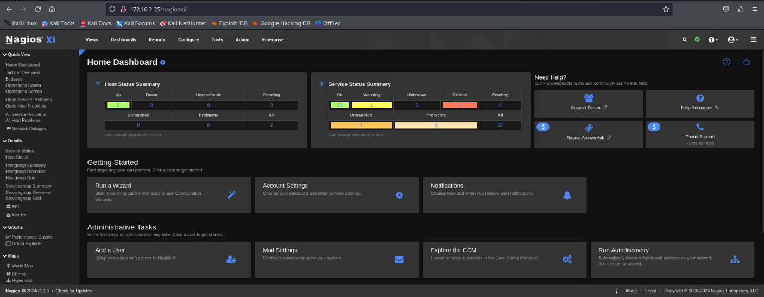

To add a new host we need to follow the steps:

1. Scan the network for running hosts with auto-discovery configuration wizard

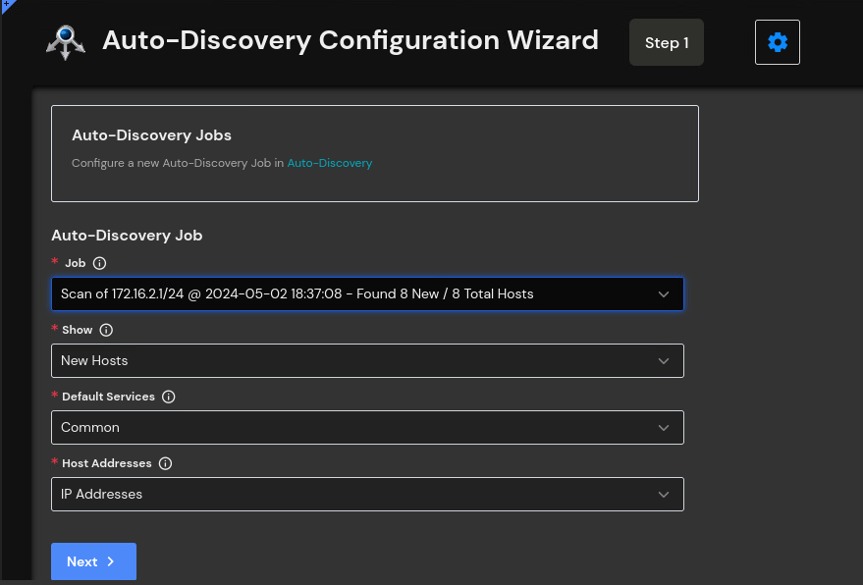

1. After the wizard has finished a list of the running hosts will appear from which we have to select the desired places where we will install the agents.

If it says success, it means that the agents are installed and we can confirm that when going to the main dashboard and checking the number of the hosts.

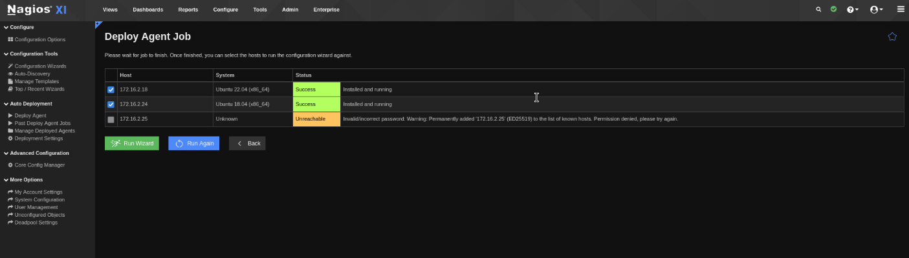

We can also adjust the settings of the notifications of the platform, for example, to notify upon a certain amount of CPU usage.

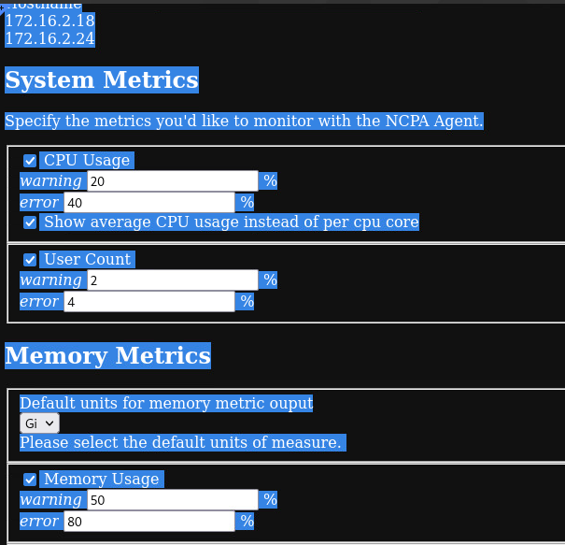

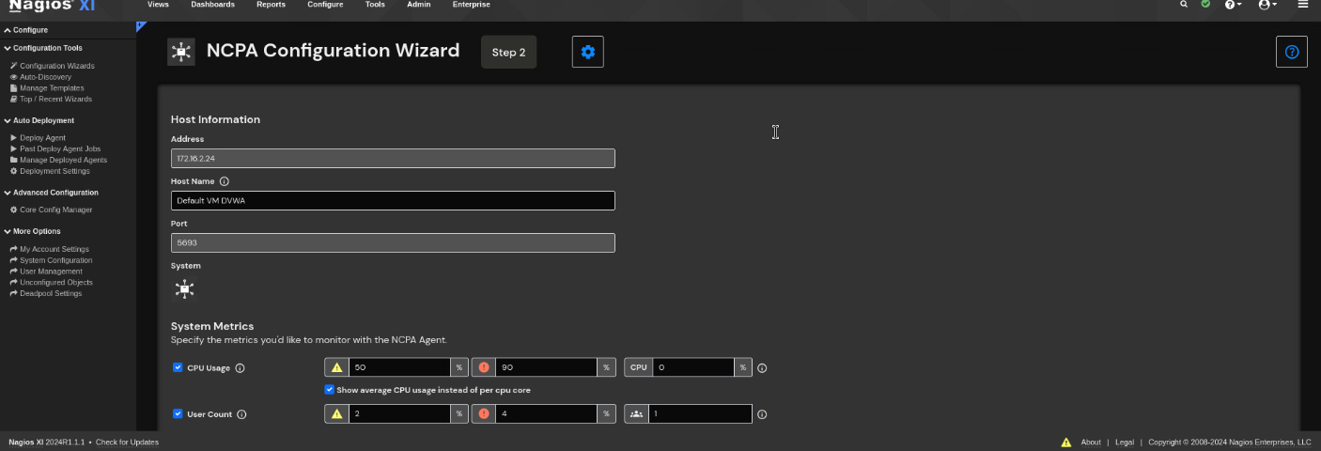

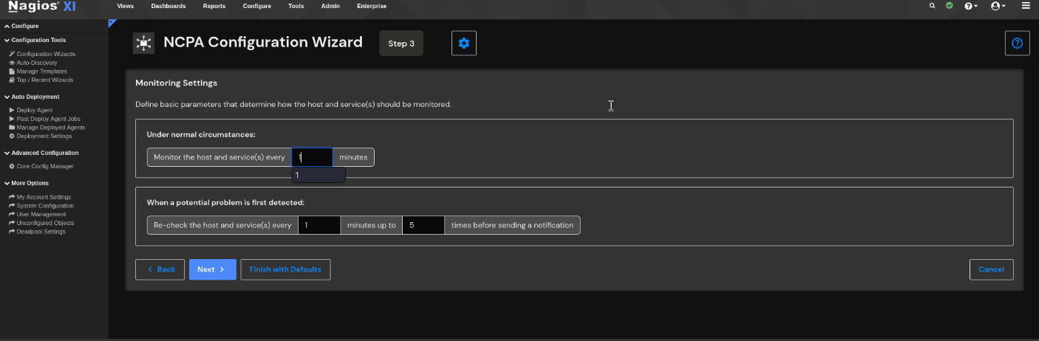

After completing the steps we can see more in-depth info about the status of the device:

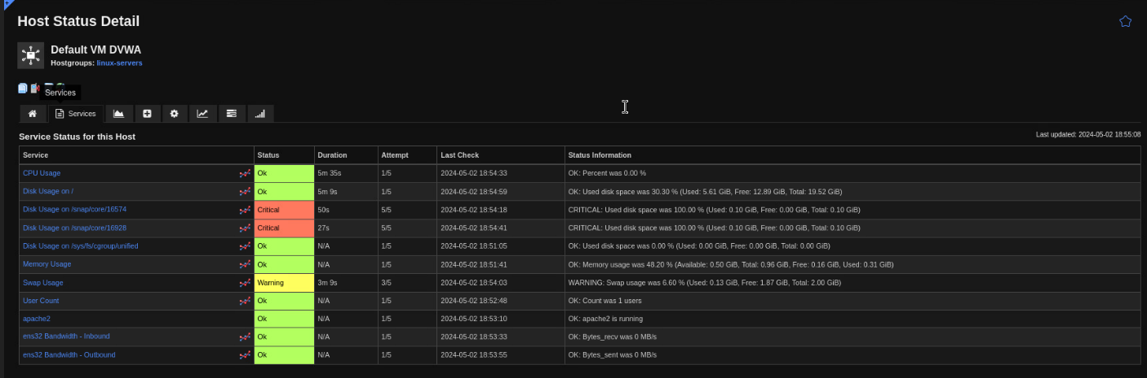

To test if the monitoring really works I will do a stress test with a npm on the CPU of the DVWA server and check the graph in Nagios:

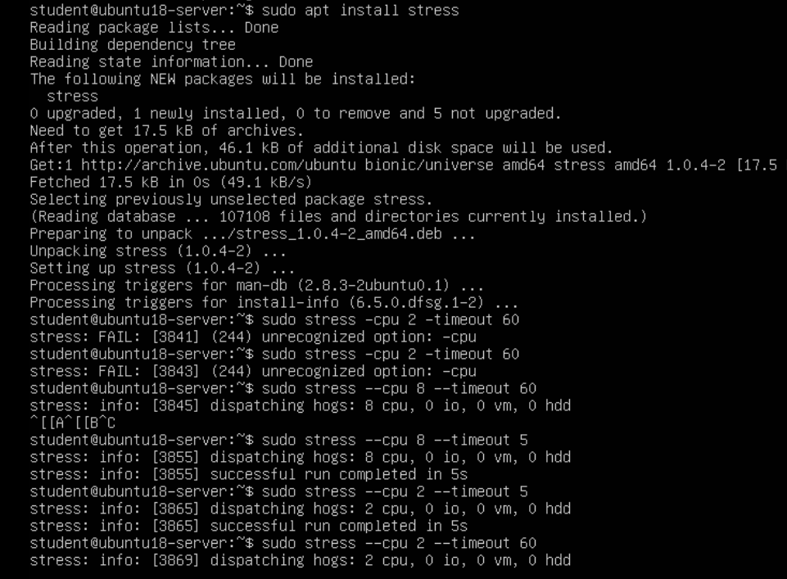

We run it for 2 CPU cores for 60 seconds timeout and then we go to Nagios’s Graph:

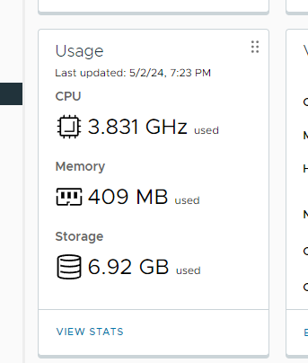

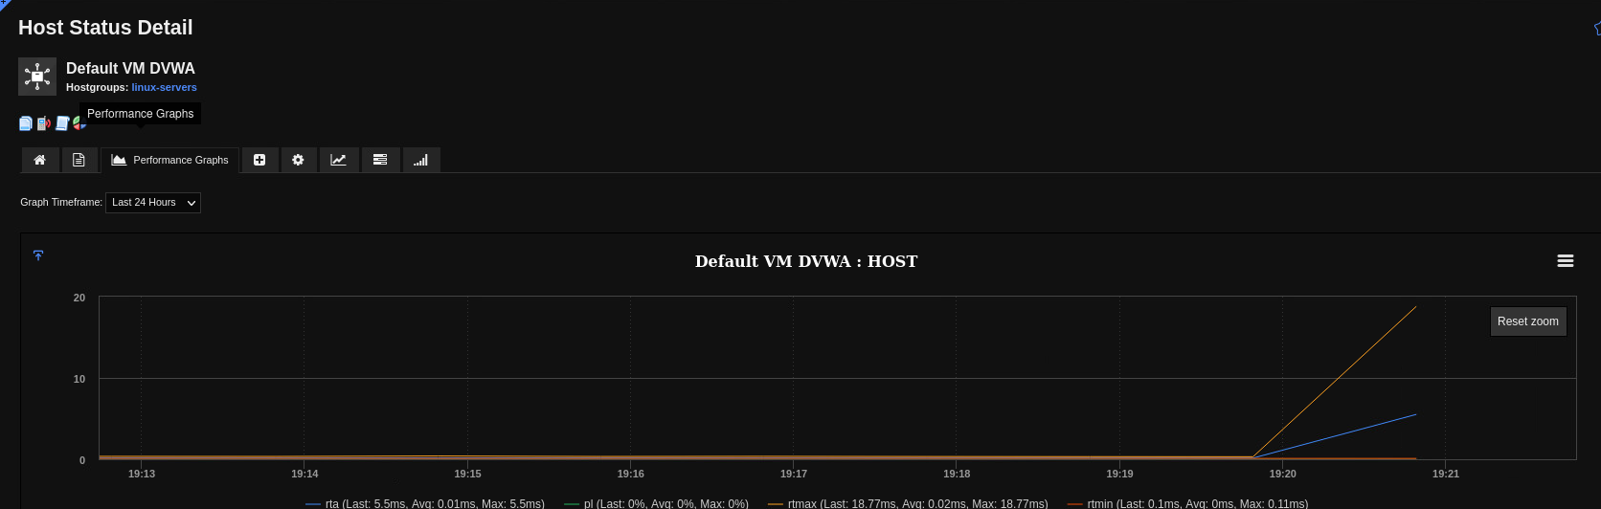

We can see when the CPU’s usage has risen.

And after we stop the stress test the graph goes back to low:

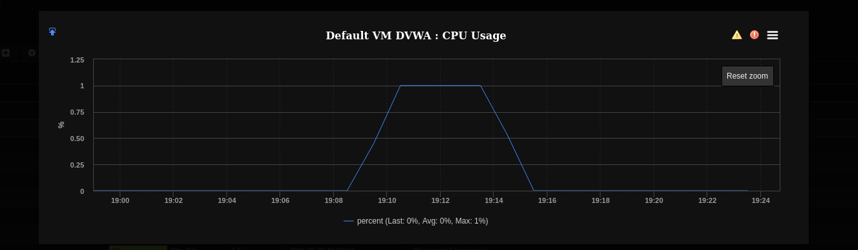

* 1. Docker and Container Security

Docker security might be exploited due to two main reasons:

1. Configuration issues by inexperienced engineers, giving too many privileges, setting up a weakly protected network, using outdated images, etc.
2. Bugs in containerization software itself, e.g. CVE's.

For this exercise, we are going to use exactly that- a vulnerable Docker machine and we’ll try to hack it. The file can be downloaded from the sources below.

So after attaching it to a local VM and assigning it with another machine to a NAT Network and booting them, both machines should look like this:

(Ref 1, 3)

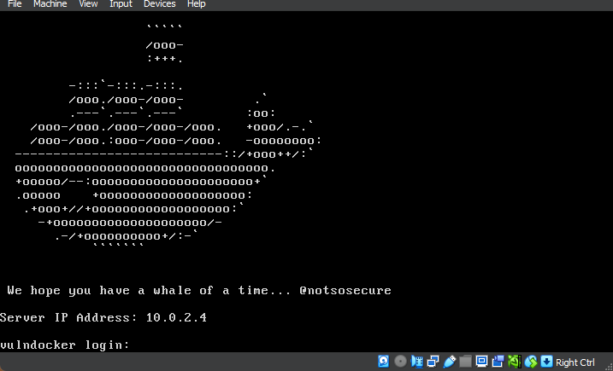

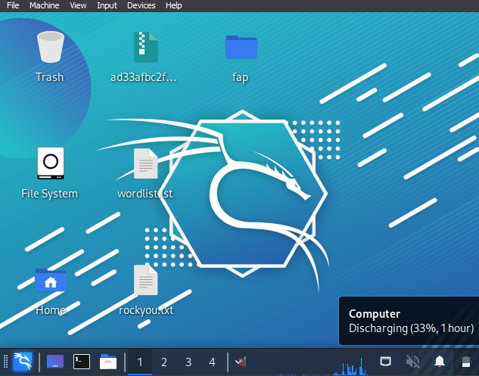

The assigned IP addresses for the machines are:

Docker: 10.0.2.4

Kali Linux: 10.0.2.15

The first thing that we can do to start our attack is to do a scan from our Kali Linux for different things in the network:

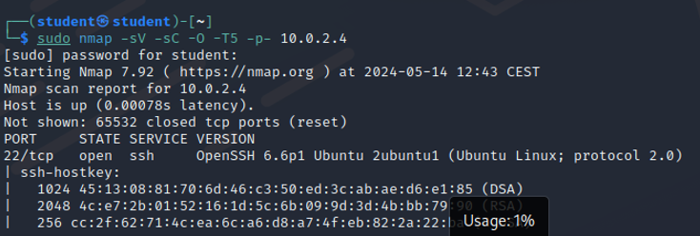

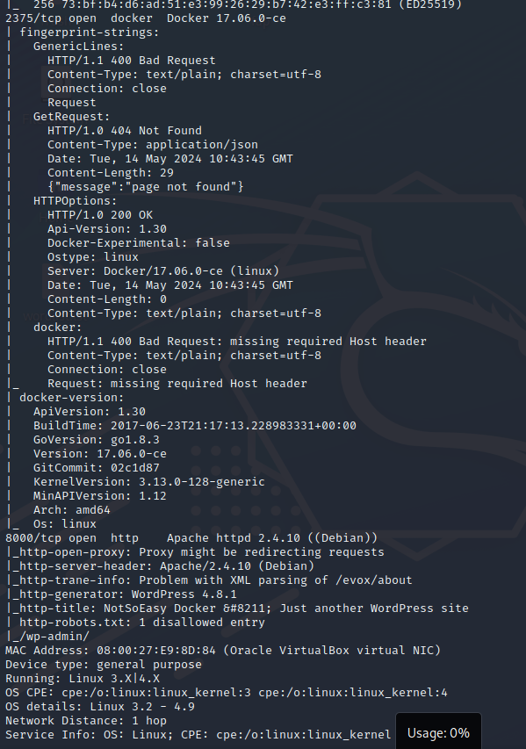

From the scan, we can see that the Docker has an open port. We also can see the version of it. The main problem here is that the SSH port is exposed, which lets us run commands remotely to the container.

Now we will run a command to display the available images:

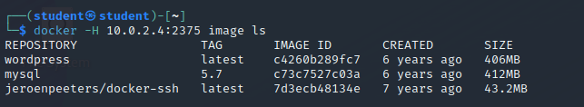

And also, the containers:

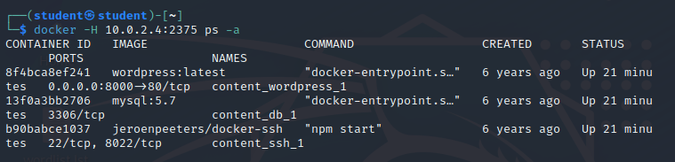

We can also see the network:

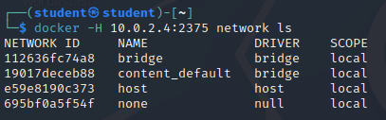

From those outputs, we can get valuable information about which containers run on which ports. In this case, we see a WordPress site running on port 8000.

Let’s navigate to the website from our browser:

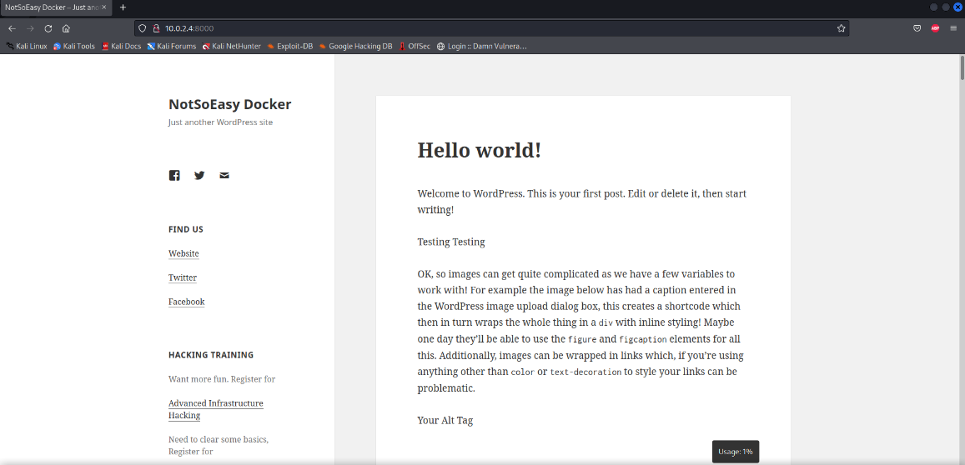

We will perform a wpscan on the URL and enumerate users, pages and others:

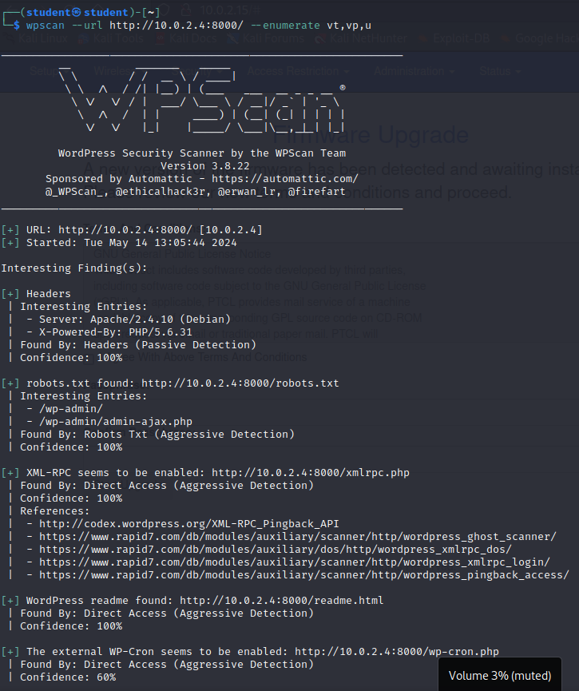

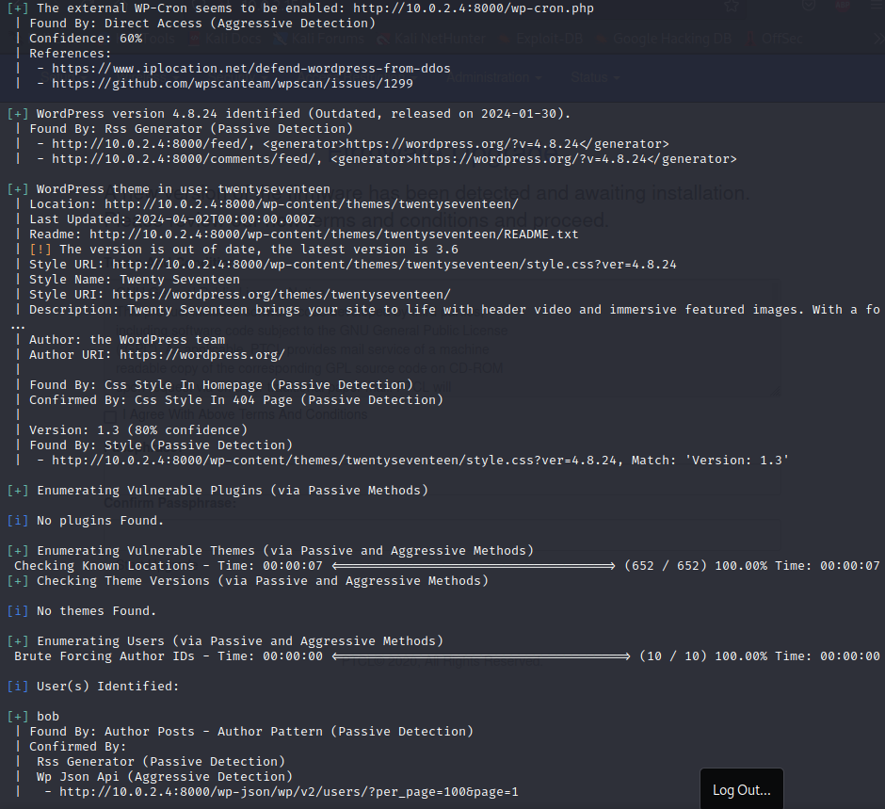

From the log we don’t see any plugins that can be exploited, but we have found how to access the admin page and one user named Bob.

We suppose when Bob Is the only user of the page, he might be an admin. So we will try to brute force the password and log in with this user. For now we know that the structure should look like this:

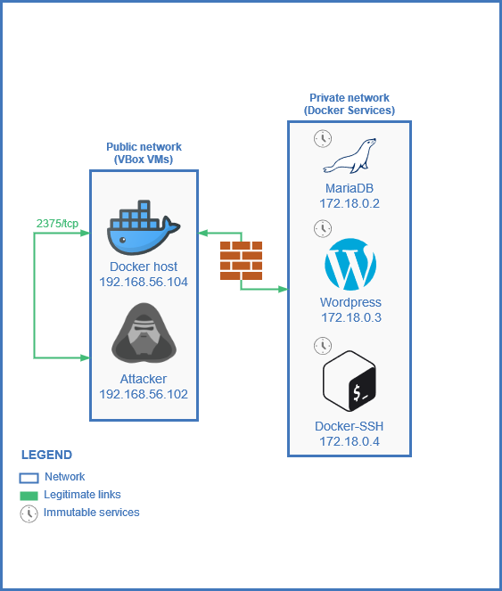

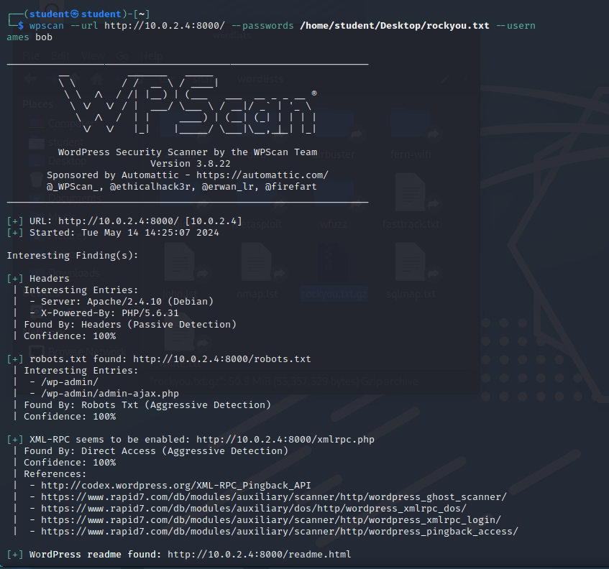

We specify the URL, the password list, which in this case will be the default one from Kali Linux and the username Bob.



After a long search for passwords, the program finally found a match:

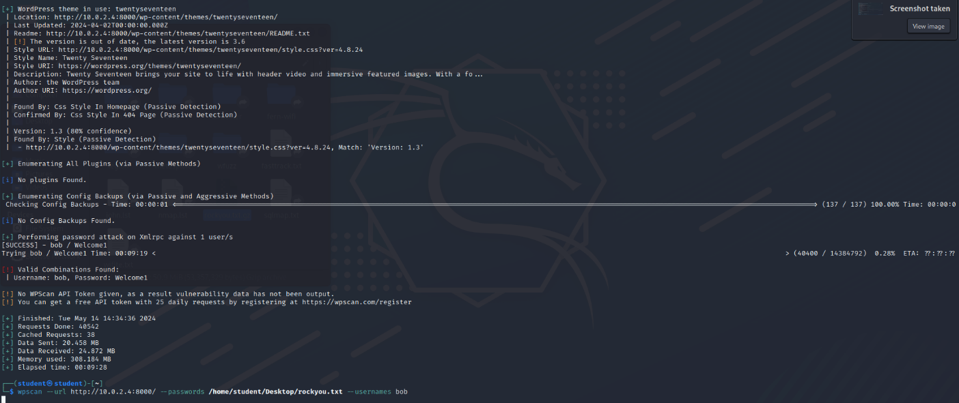

As you can see the valid combination is bob/ Welcome1, found for 9 minutes of search.

After logging in the site the first flag waits for us:

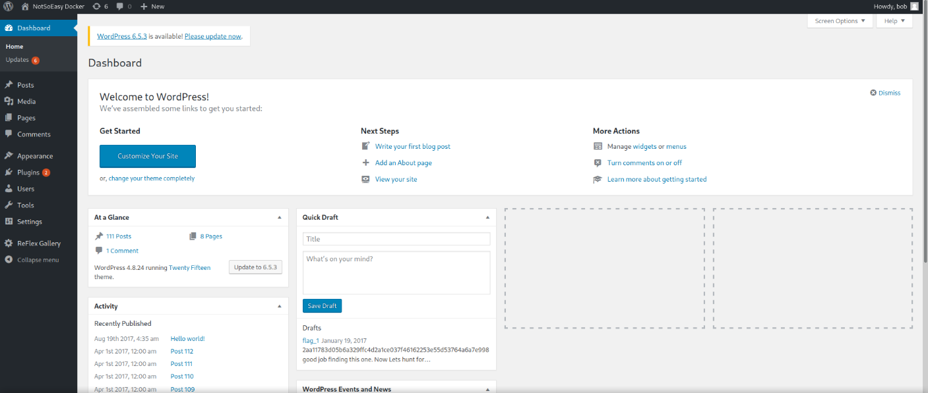

Now it’s time to do a reverse shell that will gain us access to execute commands. A reverse shell gives permissions from the host to the attacker, usually through a backdoor in the app like a plugin – in our case a vulnerable web page 404. (Ref 2)

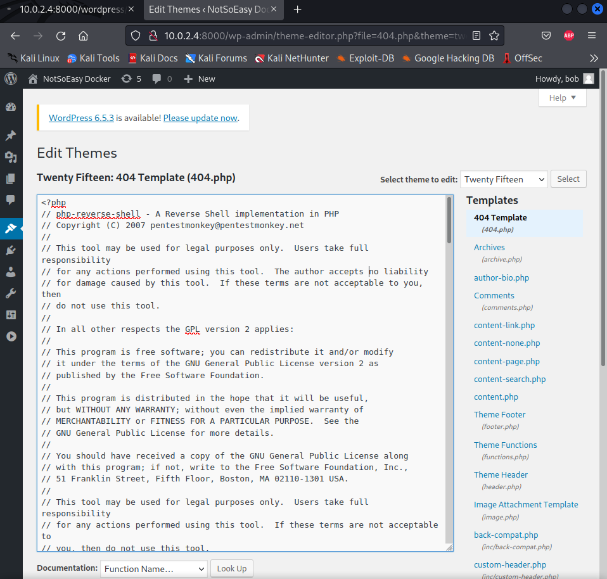

The code for the exploit, you can find in sources. Now when visiting the page we will listen for port 1234 (set in the PHP file) on our kali machine and when we enter the website we will establish a connection to the shell terminal

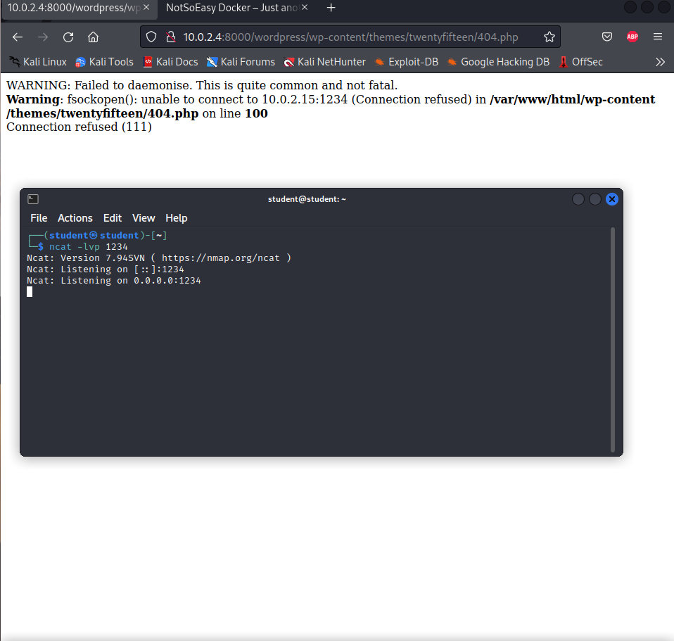

Now I will reload the page:

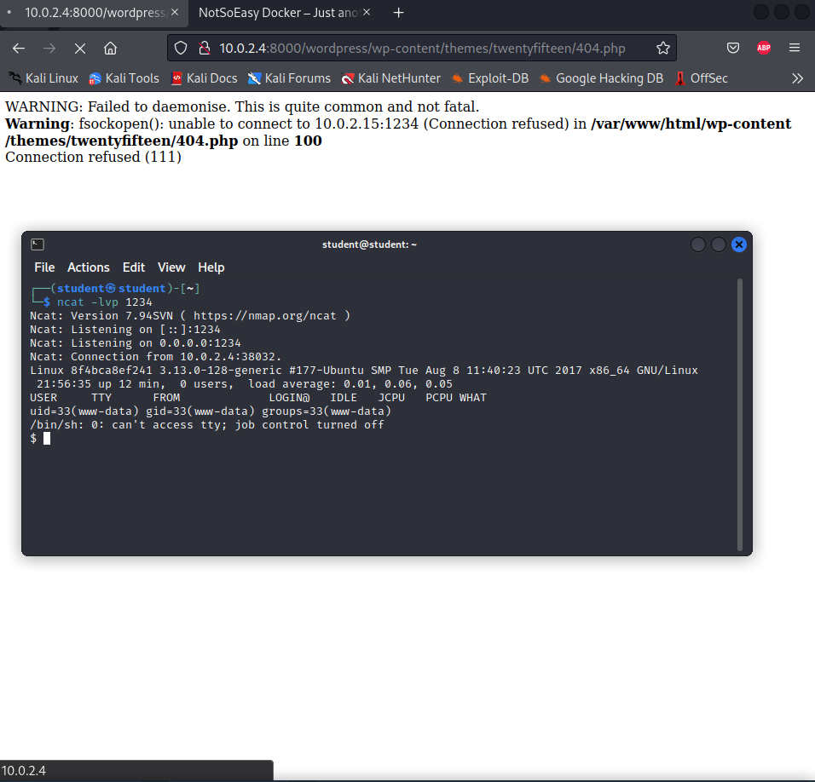

So now we can search for any flags in the container:

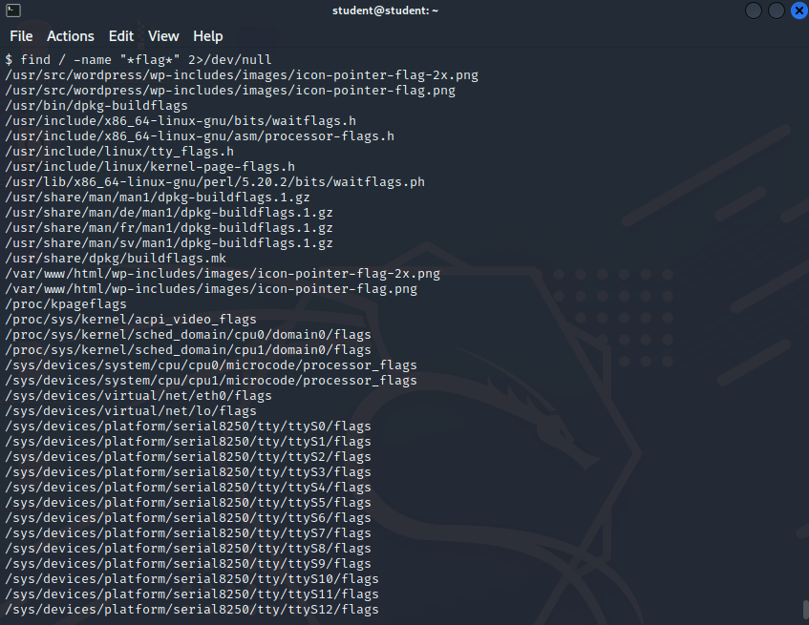

So far I couldn’t find any flag so we will search in another container.

We saw from the nmap scan that there is an open docker API connection, so lets try to get in there:



So we are deploying a container using the API and then we point the volume of that container to the root directory and we can see that right away after ls-ing in the root folder there is the flag that waits for us:



And when we nano the file we see the string of the third flag:

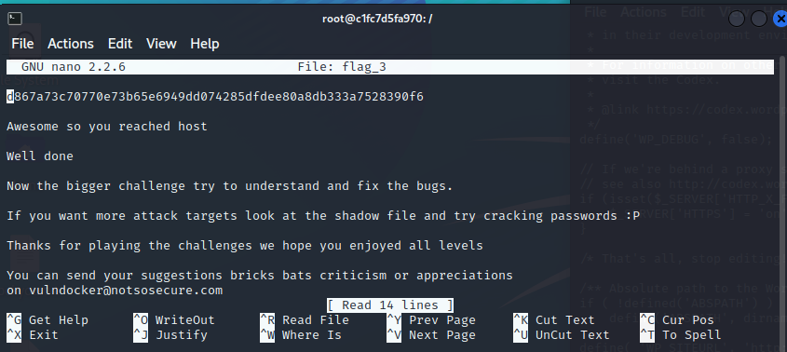

2.6 Identity and Access Management

In every organization, there is some sort of access hierarchy. It is important to give permission to employees and people from the company to places, machines, computers, etc. for them to do their jobs. Most of the time people need access to a certain range of things, that’s why it is important to restrict access outside that range. This is called separation of concerns. In this topic, I’ll develop a role structure and policies for a small virtual company.

First, we need to divide the users in three different ways:

1. Full-access employees(admins).
2. Employee-access
3. Guest-access

**Administrator Role (Admin)**:

Responsibilities:

1. Full access to all systems, applications, and data.
2. User management, including creating, modifying, and deleting user accounts.
3. System configuration and maintenance.

Members:

CEO

IT Managers

**Employee Role**:

Responsibilities:

1. Access to department-specific applications and data.
2. Collaboration tools.
3. Read/write access to departmental files and folders.

Members:

Marketing Team

Sales Team

Development Team

Human Resources Team

**Guest Role**:

Responsibilities:

1. Limited access for external contractors, auditors, or temporary workers.
2. Access to specific resources as needed, with restricted permissions.

Members:

External Contractors

Auditors

In every company, some security rules need to be followed to keep data protected like employees having strong passwords. I constructed some general rules and policies:

1. **Password Policy**:

Passwords must be at least 8 characters long and contain a mix of uppercase letters, lowercase letters, numbers, and special characters.

Passwords expire every 90 days (common practice).

1. **Data Access Policy**:

**Confidential Data**:

Only Admins and specific employees with a need-to-know basis have access.

Access to confidential data is logged and monitored.

**Sensitive Data**:

Access is restricted to employees within the respective departments.

Access is granted based on job roles.

Read-only access is provided to certain employees upon request.

1. **Network Access Policy**:

**Remote Access**:

Employees can access the network remotely using a VPN.

VPN access requires two-factor authentication.

**Guest Access**:

External contractors are granted access to a separate guest network with limited permissions.

Guest network access expires after the contract ends.

1. **System Access Policy**:

Admins have full access to system resources.

Regular employees have access to necessary applications and files based on their job roles.

Access requests for new applications or resources are reviewed and approved by department heads.

# BoK Specialist

The "BoK Specialist" phase runs from weeks 13 to 15 and deals with specialistic topics of your interest, see Canvas.

* 1. Secure Software Design

I did extensive research regarding the topic of Secure Software Design by exploring different Principles Documents by NSA | FBI | ACSC | NCSC-UK | CCCS | BSI | NCSC-NL | CERT NZ | NCSC-NZ, etc.

A software product to be secure by design is critically important because as only one example, cyber breaches have resulted in hospitals canceling surgeries and diverting patient care globally. That is why now more than ever, it is fundamental for technology manufacturers to make Secure-by-Desing and Secure-by-Default the focal points of product design and development processes. The authoring agencies strongly encourage every tech manufacturer to build products that don’t let customers constantly perform routine updates, and monitoring and to always be concerned about security. It has been a fact that companies rely on later fixing of vulnerabilities after the publication of software, requiring the customers to apply patches at their own expense and security considerations. Nowadays high standards of software security are prioritized above all features and speed capabilities.

Secure by design means that technology products are built in a way to protects the customer from cyber attacks. Software manufacturers should perform risk assessments to address potential issues and then include protections in product blueprints.

Sometimes they are encouraged to make hard tradeoffs regarding features for security updates that may not be visible to customers, such as migration to Memory Safe Programming Languages such as C#, Ruby, Java, Go, and Swift (Ref 6). In this case, protecting the customer is a higher priority than providing them a fancy product features that seem appealing but enlarge the attack surface.

To be Secure-by-Default means products are protected from attacks directly out of the box without additional charges from the customer side and without the need of tweaking settings beforehand. In a nutshell - the complexity of security configuration should not be a customer problem and additional security configurations are included in the base product like seatbelts are included in all new cars.

Software manufacturers should have a policy to maintain an open line of communication for feedback internally and externally regarding product security issues. Software security should be emphasized in internal forums, as well as external product marketing and customer engagement.

A good practice is also having an established vulnerability disclosure program that allows security researchers to report weak spots and receive legal safe harbor for doing so.

Some Secure-by-Design tactics include acquiring and maintaining well-structured software components from verified commercial, open source, and other third-party developers to ensure robust security in consumer software products, using web template frameworks that implement automatic escaping of user input to avoid web attacks such as cross-site scripting.

Some more tactics include using parameterized queries rather than including user input in queries to avoid SQL injection attacks, as well as good testing including unit and integration.

A common mistake is to design an infrastructure so that the compromise of a single security control results in the compromise of the entire system. That can be avoided if user privileges are narrowly provisioned and access control lists are employed.

Furthermore, eliminating default passwords and establishing Multifactor Authentication for privileged users is also an important tactic to be mentioned.

Finally, when leveraging cloud systems, the client should have clarity on the supplier’s security responsibilities and prioritize cloud providers that are transparent about their posture, internal controls, and the ability to live up to their obligations under the shared responsibility model.

With all this information considered, I will now look into my previous projects at Fontys and double-check if everything recommended on this topic is applied to the best extent.

All my projects so far have a memory-safe language. In my latest project, the user roles are divided, so that if one gets compromised, the parts that this role is not responsible for will stay intact.

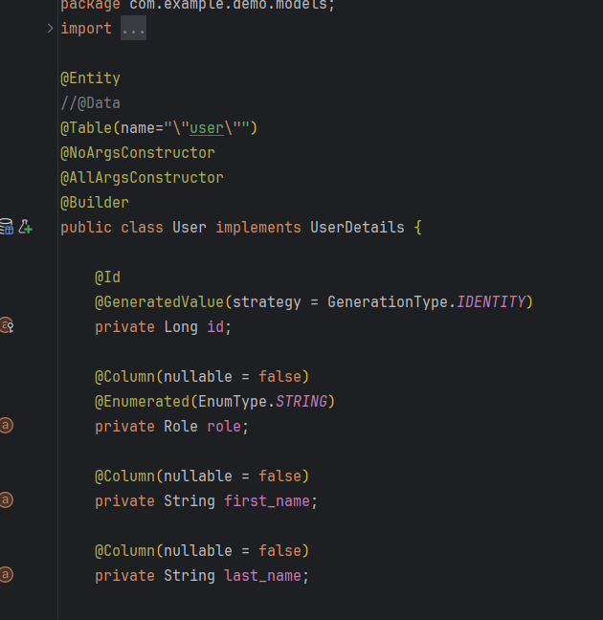

As you can see the roles of the users are predefined when they are created and stored in the database. For example, a student, a teacher and an admin, those three roles sever three different purposes. A student is mainly able to observe grades, announcements, his/her info, contact info of teachers, grade statistics, etc, whereas a teacher can assign grades, edit announcements and input data regarding the students. The administrator cannot do anything from the description, but he/she is rather responsible for the administrative process, such as giving information about the status of the platform, recent or upcoming updates, seeing the information from the contact form that people submit, etc.

I have also tried to minimize the user input and make wherever I can, the fields predefined with value to be selected, instead of inputted. This protects the website and the structure from different SQL Injection attacks.

Also in my login page, I have created a validation check that checks with my own API the status of the requested authentication with Authentication Token, which is claimed to be one of the most famous and secure methods for authentication.

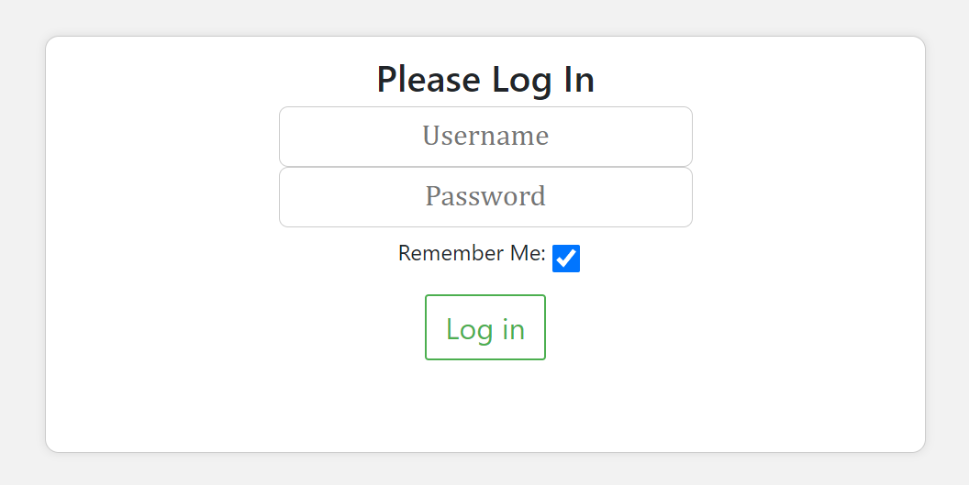

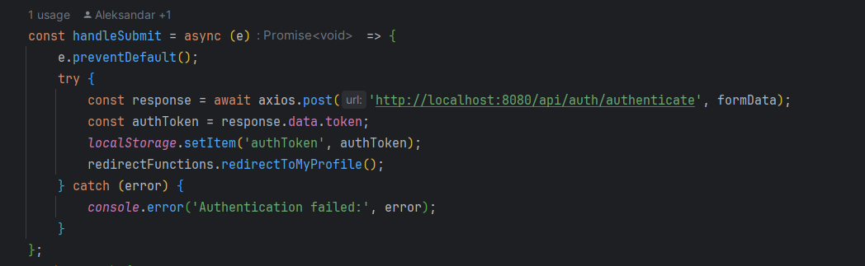

I have also opened a contact field, that would be really helpful for users and developers if any bug arises. Leaving an open line for communication is crucial for ensuring constant feedback on your product.

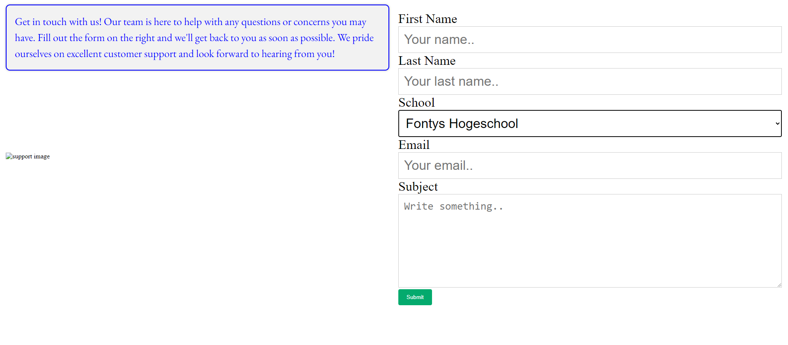

* 1. Operating systems

I will get into this topic with the following content:

* Computer Hardware and Software Structure
  + What are registers and how are they used?
  + What is an instruction pointer and how does it work?
* Operating System Services
* Multiprogramming vs Multitasking vs Multiprocessing
* Memory Management
  + What is a stack and how does it work?
  + What is a heap and how does it work?
* Windows and Linux Architecture Overview

Computer Hardware and Software Structure

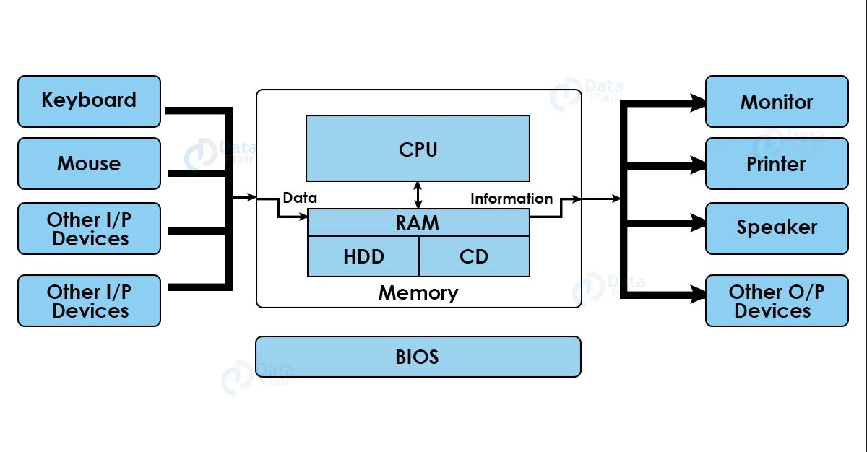

This is usually how a computer is structured. It consists of hardware and software parts.

The CPU is the “brain” of the computer. The RAM provides information to the CPU, which is power-dependent, unlike the HDD/SSD, where information is stored even if the computer is turned off. All that sits on a software and hardware platform called the motherboard, which has a chipset and components of its own that establish the connection between the hardware parts in the computer.

What are registers and how are they used?

CPU registers are temporary storage devices that are built into the CPU. When you give instructions to the CPU it stores the data into the registers until the process is completed. Registers can hold data, instructions, and addresses. CPU registers are classified into 6 types based on their functions:

* Memory Address Register (MAR)
* Memory Buffer Register (MBR)
* Memory Data Register (MDR)
* Instruction Register (IR)
* Program Counter (PC)
* Accumulator

What is the difference Between cache Memory, RAM, and Registers?

Cache Memory & RAM are also storage devices that hold data temporarily.

Hence, most people are confused between the three.

To explain in simple words, Registers store the data before processing, RAM stores the data during the process, and Cache Memory stores the data after processing.

Let’s take an office as an example. Cache memory is like the cabinet desks where you store the frequently used data. Now, suppose your boss has given you a new project (instruction). You will keep the files on your working desk, analyze them, and then store them in your cabinets or storage. Similarly, when you give the CPU any instructions, it puts the information in the registers, processes it, then stores it on the Cache, or Hard Disk. Here some of the differences: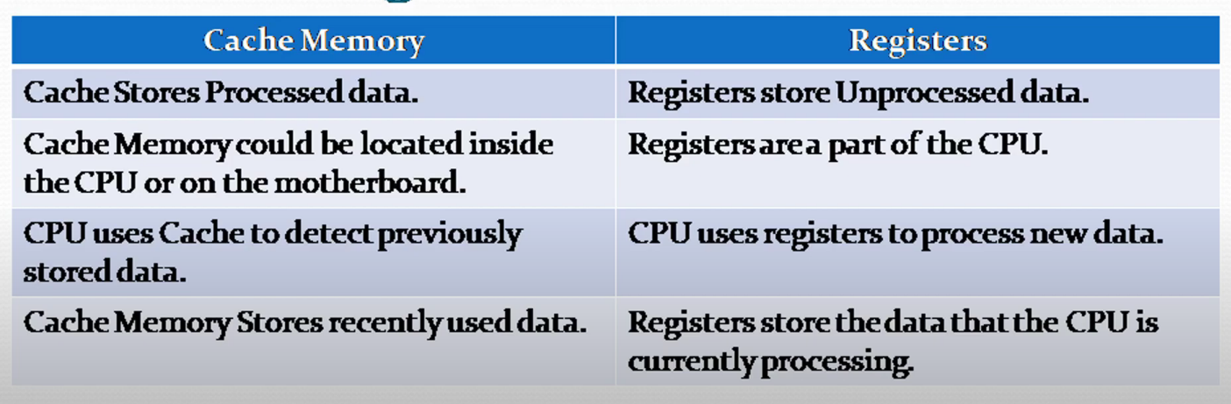

Register size determines how much info the CPU can store in it. A register can be of sizes 1 Bytes, 2 Bytes, 4 Bytes, 8 Bytes, or 16 Bytes. Having a bigger size Register can increase the performance of the CPU.

CPU Registers are not only faster than Cache 7 RAM, but are the fastest type of storage in a computer. Registers are also the most expensive type of computer memory.

(Ref 11)

What is an instruction pointer and how does it work?

In a nutshell, its primary function is to keep track of the address of the next instruction to be executed in a program. The instruction pointer holds the memory address of the next instruction to be fetched and executed by the CPU.

As each instruction is executed, the instruction pointer is updated to point to the following instruction in the sequence. In most programs, instructions are executed sequentially.

After executing an instruction at a given address, the instruction pointer is incremented to point to the next instruction. This increment is typically by the size of the instruction just executed. For non-sequential execution, such as jumps, branches, or function calls, the instruction pointer is updated to the target address specified by these instructions.

This allows the CPU to execute instructions out of the regular sequence based on program logic.

How does it work? –

Initialization: When a program starts, the instruction pointer is initialized to the address of the first instruction of the program.

Fetching: The CPU fetches the instruction at the address pointed to by the instruction pointer.

Execution: The instruction is decoded and executed by the CPU.

Updating: The instruction pointer is updated to the address of the next instruction, either sequentially or as determined by control flow instructions.

Operating System Services

The main operating system services are Program Execution, I/O Operations, File System Manipulation, File Communications, Error Detection, Resource Allocation, Protection and Security.

Program Execution includes all operations executed on the computer.

I/O operations control the input and output of devices connected to the computer like keyboards, mice, monitors, etc.

File System Manipulation is responsible for files and directories in the machine that have to be used and it controls how they are managed, and File Communications takes care of how the files in the system correspond to each other.

Errors detection prevents the system from going into a state of error and detects and handles them.

Resource Allocation is also a very important system service that is responsible for how the resources of the device are spent to keep a well-maintained balance between the components The performance is measured by how quickly the running services and programs are run on the computer. Usually, when the resources are optimized the computer can run faster.

And finally, all that wouldn’t matter if the computer was not secure, both in terms of hardware and software. That’s why the operating system is responsible for securing the data from different threats. Also, by using optimized allocation of resources controlled by the OS, the computer runs smoothly and maintains a steady temperature by controlling fans, processes, and others.

Multiprogramming vs Multitasking vs Multiprocessing

Multiprogramming is a method where multiple programs are kept in the computer's main memory simultaneously. The operating system manages these programs and executes them one after another. It increases CPU utilization by organizing jobs so that the CPU always has one to execute, switches from one job to another when the running job performs I/O operations or becomes idle, and jobs are executed based on a priority system or scheduling algorithm.

Multitasking refers to the ability of an operating system to execute multiple tasks (or processes) simultaneously. This can be achieved through time-sharing, where the CPU switches between tasks so quickly that they appear to be running concurrently. It can be preemptive (OS decides when a task gets CPU time) or cooperative (tasks yield control voluntarily). It is common in modern operating systems like Windows, macOS, and Linux

and can involve both user and system tasks.

Multi-processing involves the use of two or more CPUs within a single computer system. It allows multiple processes to be executed simultaneously on different CPUs. It could be symmetric (all CPUs share the same memory and I/O) or asymmetric (one CPU controls the system, and others perform designated tasks) and enhances parallel processing capabilities.

Each method has its specific use cases and benefits, and they are often combined in modern computing environments to leverage their strengths.

What is a stack and how does it work?

Stack is a very important and popular data structure. It contains a group of elements, which are stacked on top of each other. If we want to put an element on top of the stack we use the PUSH function:

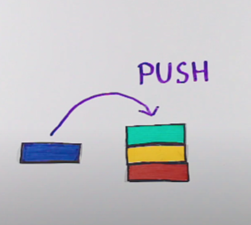

(Ref13)

If we want to remove the last element we use the POP function:

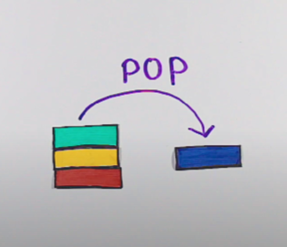

(Ref13)

And the first element that we have put will be the last to be taken off. This operation is called LIFO, which means Last in, first out.

It also has other functions like PEEK, which lets us access an element on top without modifying the stack, we can also check if it is empty and how many items it contains by calling different functions. We can also use an array for such a structure, but an array is a static data structure, exceeding the array size will cause a stack overflow. We can use the stack for example for back and forward browser features, do-redo functionality, etc.

In programming, if we want to declare a variable of a reference type, it will always be in the stack.

What is a heap and how does it work?

The Heap, unlike the stack, is dynamically allocated. Heap is NOT an implementation of heap data structure. It just uses the name and has nothing to do with it. The stack, however, IS an implementation of stack data structure.

To put a variable in the heap with languages like C and C++, we need to call different functions. In C it will be “malloc”. For an integer, “malloc” makes space of 4 bytes in the heap and returns a pointer with, for example, number 200. To put some value in the allocated space we must call a different function through a reference.

If then we declare a variable with the same name, it will point to another heap memory allocation and the old one will remain if the current language doesn’t support garbage collection. In this case we must clear the allocated space and the variable manually.

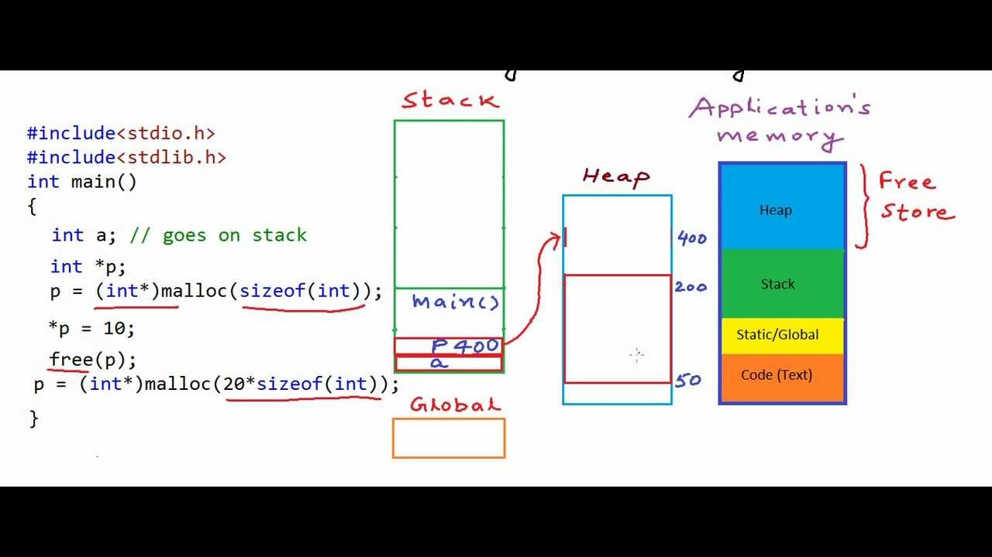

(Ref 14)

Assembly Language research

To have some more hands-on experience, I decided to do some exercises on assembly. The side I will use is mentioned at the bottom of the document (Ref 15).

Assembly language is a low-level programming language that is closely related to the machine code specific to a computer's architecture. It provides a way for programmers to write instructions in a human-readable format that a machine can understand. Machine code consists of binary instructions (0s and 1s) that a computer's CPU executes directly.

Each CPU architecture (e.g., x86, ARM) has its own specific set of machine codes.

Assembly language consists of Mnemonics, Operands, Registers, and Instructions.

Mnemonics are short, human-readable words that correspond to machine instructions, for example: “MOV”, “ADD”, “SUB”, and “JMP”.

Operands are the data or addresses on which the instructions operate Like Registers, memory addresses, and immediate values (constants).

Registers are small, fast storage locations within the CPU (explained above), where common registers include AX, BX, CX, and DX in x86 architecture.

Instructions consist of a mnemonic and operands, we will see them a bit later.

The basic assembly language instructions are data movement, arithmetic and control flow.

Data movement instructions include “MOV destination, source”, which copies data from the source to the destination, for instance, ‘MOV AX, BX’, which copies the value in register BX to register AX.

My first ever assembly language program is Hello World from a website (ref 15)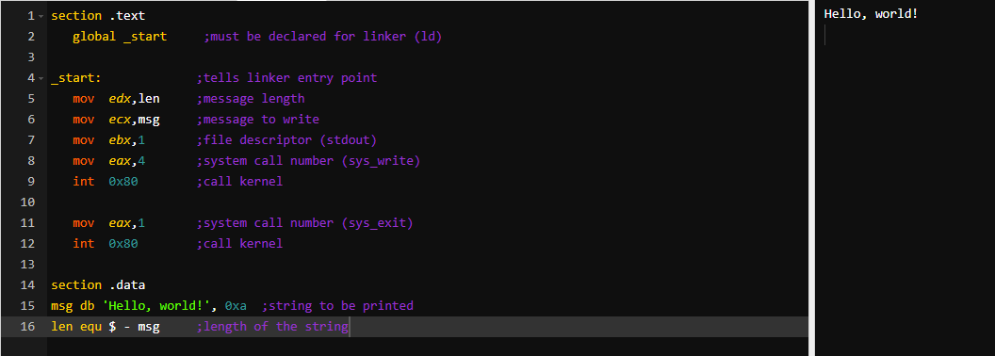

INC COUNT ; Increment the memory variable COUNT

MOV TOTAL, 48 ; Transfer the value 48 in the

; memory variable TOTAL

ADD AH, BH ; Add the content of the

; BH register into the AH register

AND MASK1, 128 ; Perform AND operation on the

; variable MASK1 and 128

ADD MARKS, 10 ; Add 10 to the variable MARKS

MOV AL, 10 ; Transfer the value 10 to the AL register

Interestingly, I found out that if you replace the section keyword with segment, you will get the same result:

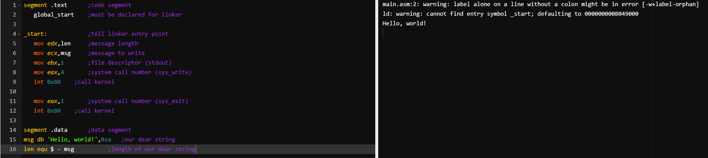

The syntax for storage allocation statement for initialized data is –

[variable-name] define-directive initial-value [,initial-value]...

Where, *variable-name* is the identifier for each storage space. The assembler associates an offset value for each variable name defined in the data segment.

There are five basic forms of the define directive –

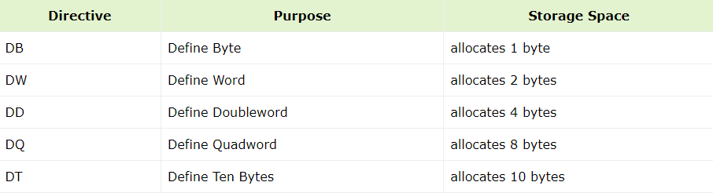

Following are some examples of using define directives −

choice DB 'y'

number DW 12345

neg_number DW -12345

big_number DQ 123456789

real_number1 DD 1.234

real_number2 DQ 123.456

The following program shows the use of define directive:

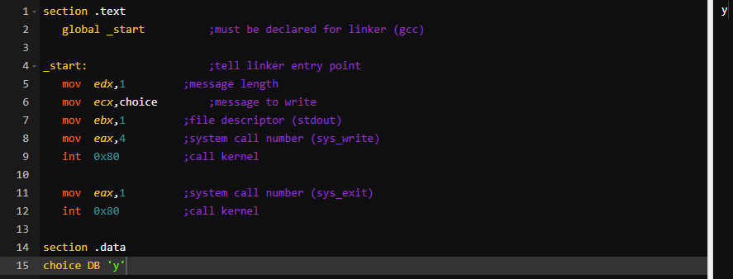

The INC instruction is used for incrementing an operand by one. It works on a single operand that can be either in a register or in memory.

The INC instruction has the following syntax −

INC destination

The operand *destination* could be an 8-bit, 16-bit or 32-bit operand.

### **Example**

INC EBX ; Increments 32-bit register

INC DL ; Increments 8-bit register

INC [count] ; Increments the count variable

## **The DEC Instruction**

The DEC instruction is used for decrementing an operand by one. It works on a single operand that can be either in a register or in memory.

### **Syntax**

The DEC instruction has the following syntax −

DEC destination

The operand *destination* could be an 8-bit, 16-bit or 32-bit operand.

### **Example**

segment .data

count dw 0

value db 15

segment .text

inc [count]

dec [value]

mov ebx, count

inc word [ebx]

mov esi, value

dec byte [esi]

## **The ADD and SUB Instructions**

The ADD and SUB instructions are used for performing simple addition/subtraction of binary data in byte, word and doubleword size, i.e., for adding or subtracting 8-bit, 16-bit or 32-bit operands, respectively.

### **Syntax**

The ADD and SUB instructions have the following syntax −

ADD/SUB destination, source

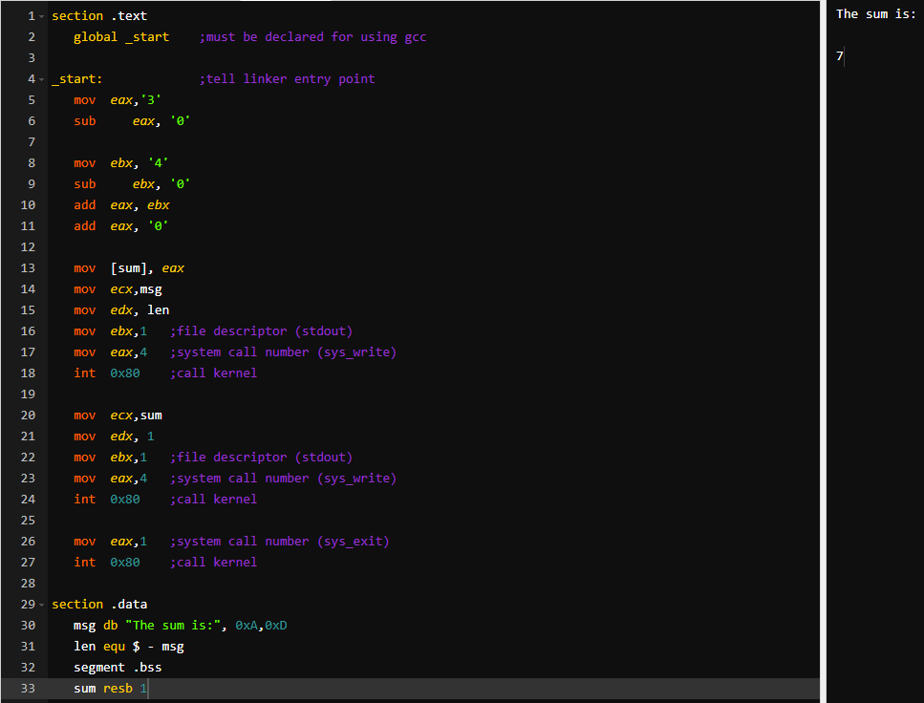

Those are some of the learning examples I ran, but assembly language is tough to deal with because it is a low-level language. Nowadays Programming languages like Python make this easier by providing human-readable text instructions which fortunately help me avoid further learning the assembly language.

# Overall Conclusion

We have covered a wide range of essential topics related to hacking, pentesting, and cybersecurity. The material is comprehensive, from understanding the basic processes to exploring advanced concepts such as network separation, VPN, and identity management. We have delved into topics such as SQL injection, network scanning, and WiFi hacking, as well as additional areas like web application firewalls and container security.

Furthermore, the specialist section covers aspects of secure design, operating systems, and other advanced topics that helped me gain thorough understanding of cybersecurity and pentesting. I can say that I am extremely proud that I have signed up for this specialization because it was a great addition to my software engineering skills and overall view of the dangers, threats, and common mistakes that people make when dealing with technology. My next step is to implement those topics when I am at my internship, if I can and to further extend my knowledge in those topics or related ones.

# References

# <https://www.vulnhub.com/entry/vulnerable-docker-1,208/>

# <https://github.com/pentestmonkey/php-reverse-shell>

# <https://gitlab.com/Creased/vulnhub-docker-writeup>

# <https://www.cisa.gov/cross-sector-cybersecurity-performance-goals>

# <https://security.googleblog.com/2019/05/queue-hardening-enhancements.html>

# <https://www.helpnetsecurity.com/2024/03/11/omkhar-arasaratnam-openssf-memory-safe-programming-languages/>

# <https://www.cisa.gov/news-events/news/cost-unsafe-technology-and-what-we-can-do-about-it>

# <https://openid.net/developers/how-connect-works/>

# <https://www.cisa.gov/sites/default/files/publications/fact-sheet-implementing-phishing-resistant-mfa-508c.pdf>

# <https://www.ncsc.gov.uk/collection/cyber-assessment-framework>

# <https://www.youtube.com/watch?v=8U8NmGokOjY>

# <https://www.youtube.com/watch?v=Z5JC9Ve1sfI>

# <https://www.youtube.com/watch?v=CgFVgp_VCN8>

# <https://youtu.be/_8-ht2AKyH4?si=ynK6Viqx6xAB2LK0>

# <https://www.tutorialspoint.com/assembly_programming/index.htm>